Making Shapes
Master 7a
Using a Block-Coding Program

Which of the images below did each set of block code create?
How do you know?
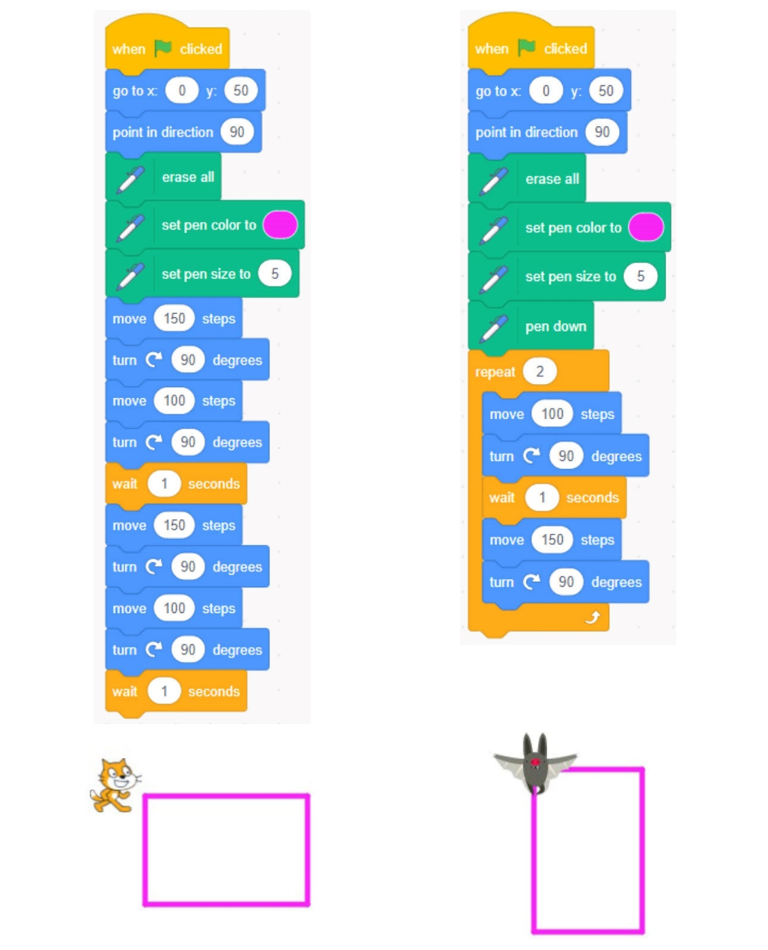
Making Shapes
Master 7b
Using a Block-Coding Program

How are the code sequences alike? How are they different?
What do you think move, turn, repeat, and point in direction might mean?
Notice the colour coding that is used to organize blocks according to function: blue indicates Motion blocks; orange indicates Control blocks, and dark green indicates Pen.

Click on the link: https://scratch.mit.edu/projects/481518787/ ,
then click at the top of the page to run both code sequences concurrently. Discuss what happens.
Does this help you decide which code goes with which sprite (Cat or Bat)? Explain.
Making Shapes
Master 7c
Using a Block-Coding Program

Part A: Altering Code to Make Matching Rectangles
In the program you looked at as a class, Cat and Bat
are drawing rectangles.
When both code sequences are run at the same time,
the rectangles overlap.
You are going to investigate how you might alter the code
so the rectangles match exactly.
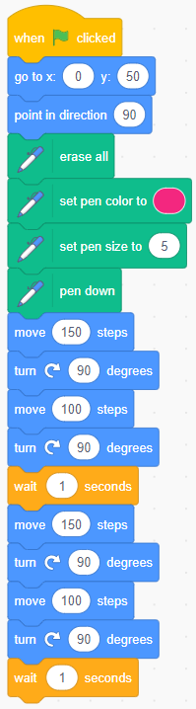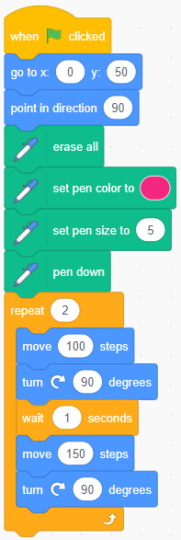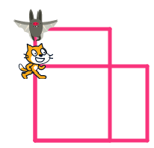
Making Shapes (cont’d)
Master 7d
Using a Block-Coding Program

What to Do
Work with your partner.
Modify this existing project: https://scratch.mit.edu/projects/481518787/
● Log in if your teacher would like you to.
● Click See Inside to alter the code
or, if you’ve logged into Scratch, click Remix to get
your own copy of this project.
● Alter the code so that the rectangles overlap and match exactly.
● Change some of the numbers, then see how your changes impact
the outcome (what Cat or Bat draws).
● Talk about what you’re changing and why.
Change just 1 thing at a time!

Did you use a Repeat Block to make the code more efficient? Explain.

Challenge:
Alter the code to make different overlapping quadrilaterals.
Making Shapes (cont’d)
Master 7e
Using a Block-Coding Program

Part B: Altering Code to Make Different Quadrilaterals
Modify this existing project: https://scratch.mit.edu/projects/552699263/

Cat and Basketball are trying to create quadrilaterals.
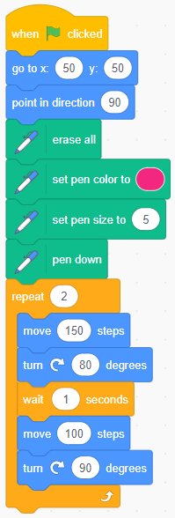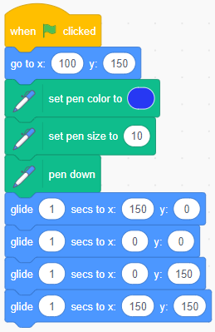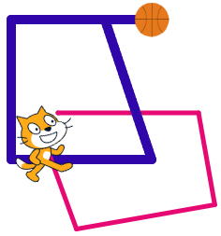

What do you notice about these code sequences?
How do you change the pen colour? Thickness?
Notice the repeat and the glide to (x,y).

Making Shapes (cont’d)
Master 7f
Using a Block-Coding Program

Are both shapes actual quadrilaterals?
Alter the code sequences to create different quadrilaterals.
Then, alter the code so that Cat’s quadrilateral and Basketball’s quadrilateral don’t overlap.

When altering concurrent code that incorporates the erase all block,
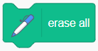
you might find it easier to remove the erase all block
and put it to the side. You can always click it in between
executing (running) the code each time.

Challenge:
Create different quadrilaterals or try making triangles.

Making Shapes (cont’d)
Master 7g
Using a Block-Coding Program

Part C: Using Conditional Statements to Make Parallelograms
Modify this existing project: https://scratch.mit.edu/projects/552702669/ | 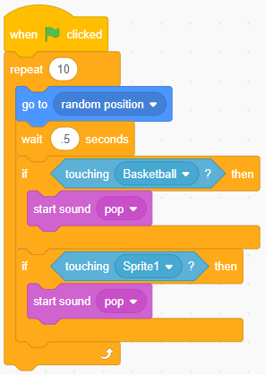
Alter the code to make parallelograms for Cat and Basketball.

Alter the code so the parallelograms don’t intersect.

Adjust the Balloon code in different ways to get used to the Conditional Statements. Consider changing the sound,
the action that occurs when the balloon is touching each sprite,
the frequency (wait time) of the balloon moving,
the number of repeats…

Challenge:
Create additional new parallelograms or triangles that don’t intersect.

Making Shapes (cont’d)
Master 7h
Using a Block-Coding Program

Tips
● You may wish to get an account and be logged in
so that everything can be saved.
● If you are logged in, when you are looking at samples,
or at your My Stuff, click See Inside to see or edit the code.
● When you click , the code executes, or “runs”.
● You can click the values in the code and change them.
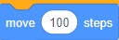
● You can click and drag any of the blocks of code out of the script
and leave them out or change their order.
● To see the code for Bat you need to click on the Bat sprite.
Right now, the code would be shown for the Cat.
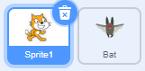
● You can move the blocks in the code to different
spots in the code to change the repeating action of your sprite
(Cat or Bat).

Making Shapes (cont’d)
Master 7i
Using a Block-Coding Program

Self-check in
What have you learned about block coding so far?
Did you get stuck? If so, what did you do?
Did you turn to your classmates for help? If so, how did they help?
What are you doing to help the learning of others?
This is “hard fun.” What do you think we mean by “hard fun”?
What other activities do you do that are “hard fun”?

