Classifying Triangles
by Side Lengths
Master 8a
Using a Block-Coding Program

Follow the link to access the file: What type of triangle?
https://scratch.mit.edu/projects/552987916/

Click See Inside.

The code for this application is incomplete.
Here is a description of the application:
● Cat asks the user to enter the number of EQUAL sides
on the triangle.
● The application checks to make sure the user doesn’t enter
a value greater than 3. If a value greater than 3 is entered,
it can’t be a triangle.
– If 0 is entered, then the triangle will be scalene.
– If 2 is entered, then the triangle will be isosceles.
– If 3 is entered, then the triangle will equilateral.

Classifying Triangles
by Side Lengths (cont’d)
Master 8b
Using a Block-Coding Program

Here is the code for the partially completed application:
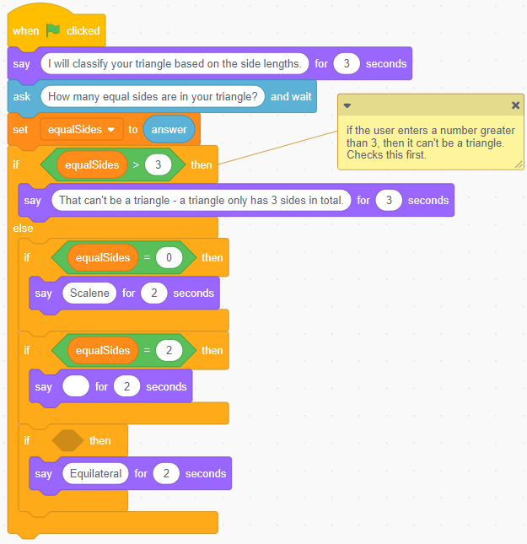

Classifying Triangles
by Side Lengths (cont’d)
Master 8c
Using a Block-Coding Program

Your task is to complete the code for the application:
Complete the Say block to indicate the type of triangle
if the user enters 2 for number of equal sides.
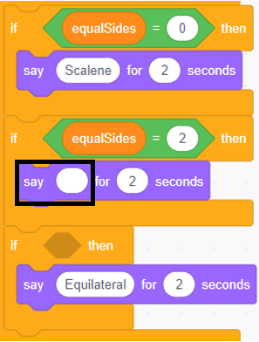

Classifying Triangles
by Side Lengths (cont’d)
Master 8d
Using a Block-Coding Program

Provide the correct condition for the equilateral triangle
in the If statement shown:
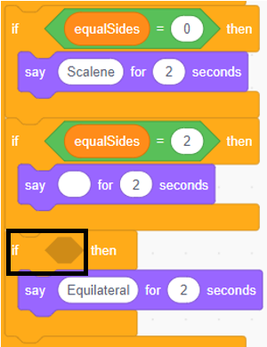
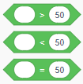
Tips:
● The conditional operator blocks ( )
can be found under Operators ().
● The variable equalSides block can be found under
Variables (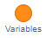).
Classifying Triangles
by Side Lengths (cont’d)
Master 8e
Using a Block-Coding Program

Follow the link to access the file: What type of triangle?
https://scratch.mit.edu/projects/552694138/
Test out the application by executing the code.
Click the green flag.
What do think this application does?
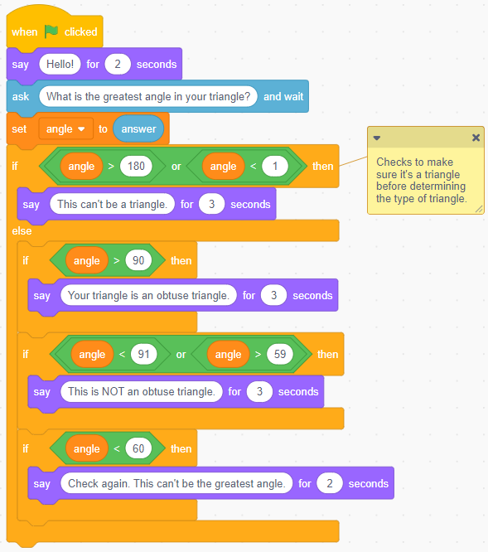

Classifying Triangles
by Side Lengths (cont’d)
Master 8f
Using a Block-Coding Program

Currently, the application shows if the triangle is obtuse or not obtuse,
based on the measure of the greatest interior angle.
The greatest interior angle must be greater than a certain measure for
the triangle to be considered obtuse. What is that measure?

How does the application know that the user has entered a measure
that can’t possibly be the greatest interior angle?
Consider what the interior angles in a triangle add to.

Try to make sense of the program by testing different measures
to see what happens.

Classifying Triangles
by Side Lengths (cont’d)
Master 8g
Using a Block-Coding Program

Follow the link to access the file: What type of triangle?
https://scratch.mit.edu/projects/552997968/
Notice that additional conditional statements (If … then) have now
been added, but the program is incomplete.
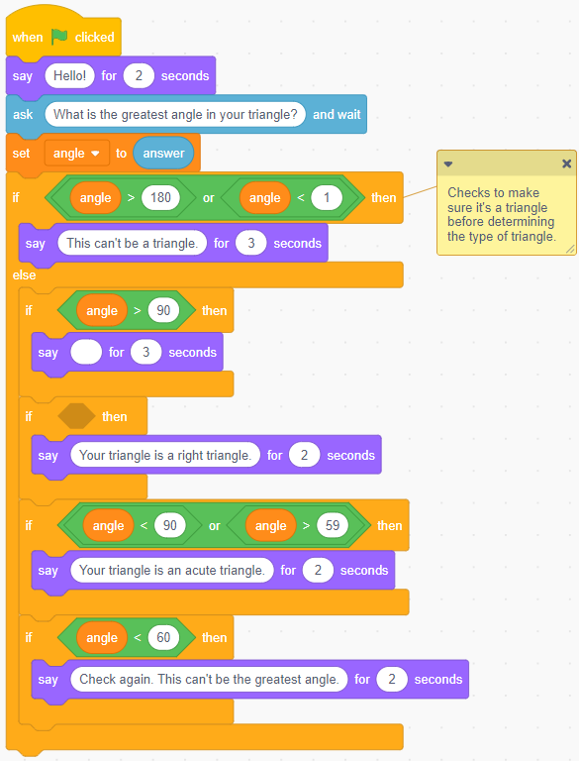
Classifying Triangles
by Side Lengths (cont’d)
Master 8h
Using a Block-Coding Program

Your task is to complete the code for the application:
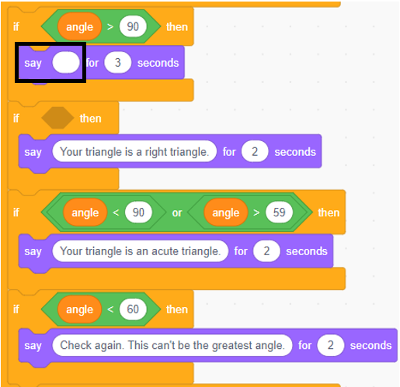

Complete the Say block to indicate the type of triangle if the user enters a measure greater than 90 for the greatest interior angle:

Classifying Triangles
by Side Lengths (cont’d)
Master 8i
Using a Block-Coding Program

Provide the correct condition for the Right triangle in
the If statement shown:
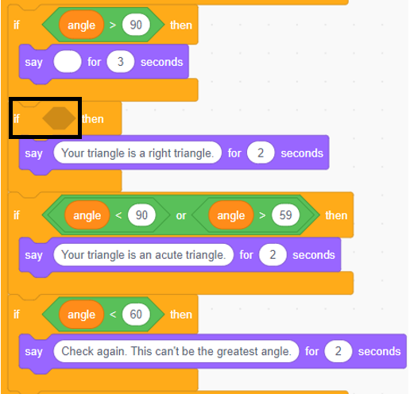
Tips:
● The conditional operator blocks ( )
can be found under Operators ().
● The variable equalSides block can be found under
Variables ().

Classifying Triangles
by Side Lengths (cont’d)
Master 8j
Using a Block-Coding Program

Challenge A
Alter the code in the Classifying Triangles based on Angles program
(https://scratch.mit.edu/projects/552694138/) so that it determines
the sum of the other two angles.

Tips:
● You will need to use an operator variable to subtract
the measure of the greatest angle from 180 to determine
what is left for the other two angles.
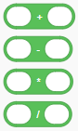

● The operators blocks ( ) are located under
Operators ().
● The variable angle block can be found under Variables ().
● You can output this information using a Say block,
found under Looks ().

Classifying Triangles
by Side Lengths (cont’d)
Master 8k
Using a Block-Coding Program

Challenge B
Alter the code to draw the type of triangle (scalene, isosceles, or
equilateral) based on the number of equal sides entered by
the user for the Classifying Triangles by Side Length application.
(https://scratch.mit.edu/projects/552987916/)
It might take a few tries to draw isosceles and scalene triangles
so that they are closed completely.

Challenge C
Alter the code to draw each type of triangle (right, obtuse, or acute)
based on the angle entered by the user for the Classifying Triangles by Angle application (https://scratch.mit.edu/projects/552997968/).
It might take a few tries to draw the right, obtuse and acute triangles
so that they are closed completely. You do not have to draw the exact
triangles based on the greatest angle measures, but be sure to draw
examples of each type of triangle.

Self-check in
What have you learned about conditions so far?
Did you get stuck? If so, what did you do?
Did you turn to your classmates for help? If so, how did they help?
What are you doing to help the learning of others?
This is “hard fun.” What do you think we mean by “hard fun”?
What other activities do you do that are “hard fun”?
Go on “spy walks” to see what your classmates have done.

