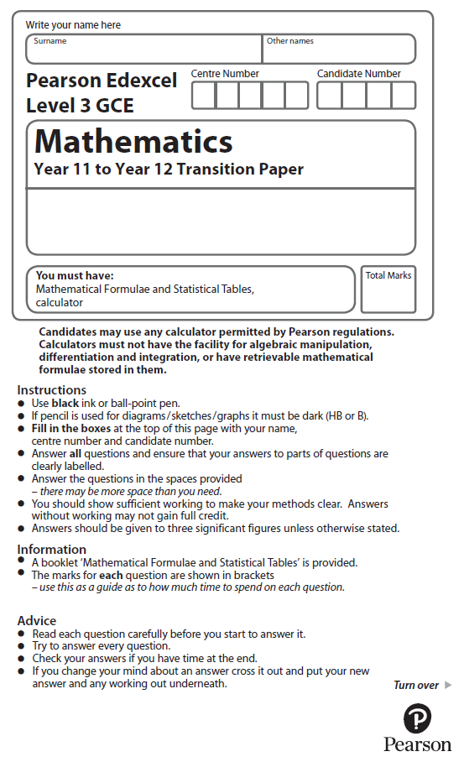

**Algebraic Expressions**

**Calculators may NOT be used to answer these questions.**

**1.** Expand and simplify (4*x* − 3)(3*x* + 1)

(Total for Question 1 is 2 marks)

**2.** (*a*)Expand and simplify (2*x* + 1)(*x* − 4)

(2)

(*b*)Expand and simplify (3*x* − 5*y*)2

(2)

(Total for Question 2 is 4 marks)

**3.** (*a*)Expand and simplify (*x* – *y*)( *x* + 2*y*)

(2)

(*b*)Factorise 12*u*2*t*2 + 18*ut*3

(2)

(Total for Question 3 is 4 marks)

**4.** (*a*)Simplify



giving your answer in the form *a*, where *a* is an integer.

(2)

(*b*)Hence, or otherwise, simplify



giving your answer in the form *b*, where *b* and *c* are integers and *b* ≠ 1.

(3)

(Total for Question 4 is 5 marks)

**5.** Simplify

,

giving your answer in the form *a* + *b*√5 , where *a* and *b* are integers.

(Total for Question 5 is 4 marks)

**6.** Simplify

(*a*) (2√5)2,

(1)

(*b*) , giving your answer in the form *a* + √*b*, where *a* and *b* are integers.

(4)

(Total for Question 6 is 5 marks)

**7.** (*a*)Factorise 24*w*2*y*3 − 8*wy*2

(2)

(*b*)Factorise 3*ef* − 3*e* + 2*f* − 2

(2)

(*c*)Factorise 25 − 4*x*2

(1)

(Total for Question 7 is 5 marks)

**8.** (*a*)Simplify 

(1)

(*b*)Simplify



giving your answer in the form , where *a*, *b* and *c* are integers and 

(4)

(Total for Question 8 is 5 marks)

**9.** (*a*) Find the value of .

(2)

(*b*) Simplify fully .

(3)

(Total for Question 9 is 5 marks)

**10.** (*a*)Simplify 

(1)

(*b*)Simplify *a*7 ÷ *a*−3

(1)

(*c*)Simplify (*x*−2)−3

(1)

 can be written in the form *d* − *q f*

(*d*)Work out the value of *d* and the value of *f*.

(3)

(Total for Question 10 is 6 marks)

**11.** (*a*)Factorise 63*x*2*d* + 9*xd* 2

(2)

(*b*)Factorise 4*ab* − 8*b* + 2*a* − 4

(3)

(*c*)Factorise *x*2 − 9*t* 2

(1)

(Total for Question 11 is 6 marks)

**12.** (*a*) Simplify

√32 + √18,

giving your answer in the form *a*√2 , where *a* is an integer.

(2)

(*b*) Simplify

,

giving your answer in the form *b*√2 + *c*, where *b* and *c* are integers.

(4)

(Total for Question 12 is 6 marks)

**13.** (*a*)Simplify ( *p*–2)–4

(1)

(*b*)Simplify 

(2)

(Total for Question 13 is 3 marks)

**14.** (*a*) Write down the value of .

(1)

(*b*) Simplify fully .

(3)

(Total for Question 14 is 4 marks)

**15.** (i) Express

(5 − √8)(1 + √2)

in the form *a* + *b*√2, where *a* and *b* are integers.

(3)

(ii) Express

√80 + 

in the form *c*√5, where *c* is an integer.

(3)

(Total for Question 15 is 6 marks)

**16.** (a) Evaluate , giving your answer as an integer.

(2)

(*b*) Simplify fully .

(2)

(Total for Question 16 is 4 marks)

**17.** Show that  can be written in the form √*a* + √*b*, where *a* and *b* are integers.

(Total for Question 17 is 5 marks)

**18.** Simplify 

(Total for Question 18 is 2 marks)

**19.** (*a*)Simplify 

(1)

(*b*)Simplify 

(2)

6*x*−2 can be written in the form *axn* + *b*

(*c*)Find the value of *a*, the value of *b* and the value of *n*.

(2)

(*d*)Expand and simplify (3*y* + 2)2 – (3*y* – 2)2

(2)

(Total for Question 19 is 7 marks)

**20.** (i)Simplify



Write your answer in the form *a*, where *a* is an integer to be found.

(2)

(ii)Solve the equation

36*x* – 3 = 81

Write your answer as a rational number.

(3)

(Total for Question 20 is 5 marks)