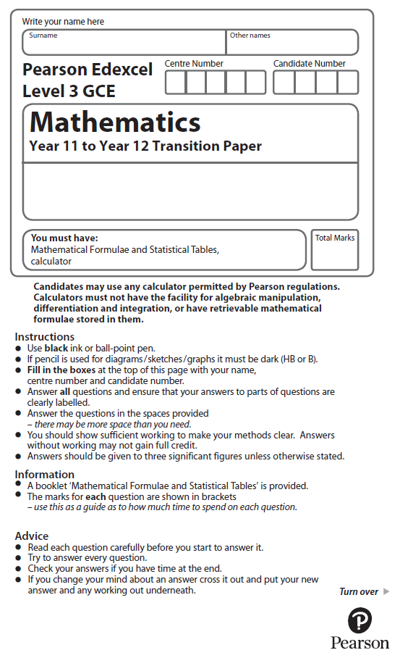

**Trigonometric Identities and Equations**

**Calculators may NOT be used to answer these questions.**

**1** Find the exact value of tan 30° × sin 60°

Give your answer in its simplest form.

.......................................................

**(Total for Question 1 is 2 marks)**

**___________________________________________________________________________**

**2** Write down the exact value of tan 45°

.......................................................

**(Total for Question 2 is 2 marks)**

**3** The table shows some values of *x* and *y* that satisfy the equation *y* = *a* cos *x*°+ *b*

|  |  |  |  |  |  |  |  |
| --- | --- | --- | --- | --- | --- | --- | --- |
| ***x*** | 0 | 30 | 60 | 90 | 120 | 150 | 180 |
| ***y*** | 3 | 1 + | 2 | 1 | 0 | 1 – | –1 |

Find the value of *y* when *x* = 45

.......................................................

**(Total for Question 3 is 4 marks)**