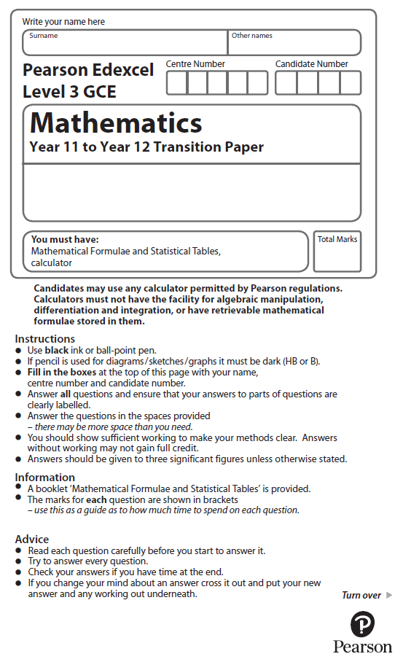

**Vectors**

Calculator Icons - Free Download, PNG and SVG**You may use a calculator to answer these questions.**

**1.** (i) Two non-zero vectors, **a** and **b**, are such that

| **a** + **b** | = | **a** | + | **b** |

Explain, geometrically, the significance of this statement.

(1)

(ii) Two different vectors, **m** and **n**, are such that | **m** | = 3 and | **m** – **n** | = 6

The angle between vector **m** and vector **n** is 30°

Find the angle between vector **m** and vector **m** – **n**, giving your answer, in degrees, to one decimal place.

(4)

 (Total for Question 1 is 5 marks)

**2.** Given that the point *A* has position vector 3**i** – 7**j** and the point *B* has position vector 8**i** + 3**j**,

(*a*) find the vector .

(2)

(*b*) Find $\vec{ \text{AB} }$. Give your answer as a simplified surd.

(2)

 (Total for Question 2 is 4 marks)

**3.** Given that the point *A* has position vector 4**i** − 5**j** and the point *B* has position vector −5**i** −2**j**,

(*a*) find the vector ,

(2)

(*b*) find $\vec{ \text{AB} }$.Give your answer as a simplified surd.

(2)

 (Total for Question 3 is 4 marks)

**4.** The diagram shows parallelogram *ABCD*.

**

** =  ** = 

The point *B* has coordinates (5, 8)

(*a*)Work out the coordinates of the point *C*.

(3)

The point *E* has coordinates (63, 211)

(*b*)Use a vector method to prove that *ABE* is a straight line.

(2)

(Total for Question 4 is 5 marks)

**5.** Here are two vectors.

 =   = 

Find the magnitude of 

(Total for Question 5 is 3 marks)

**6.**

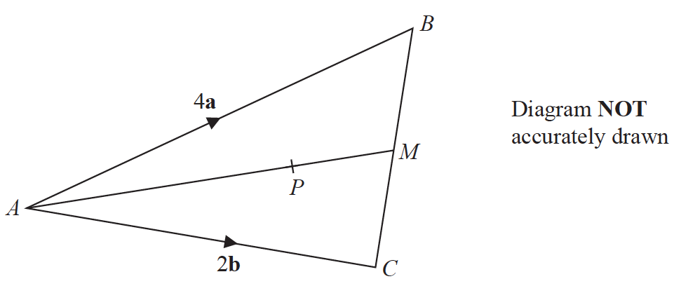

*ABC* is a triangle.

The midpoint of *BC* is *M*.

*P* is a point on *AM*.

 = 4**a**

 = 2**b**

 = **a** + **b**

Find the ratio *AP* : *PM*

(Total for Question 6 is 3 marks)

**7.**



Figure 2 shows the triangle *OAB* with ** = 2**a** and  = 3**b**

The point C lies on OA such that  = 

The point D lies on OB such that  = 

(a) Find  in terms of **a** and **b**.

(2)

The point *P* is such that *ODBP* is a straight line and *AP* is parallel to *CD.*

(b) Find  in terms of **b**.

(4)

The point Q is such that  = 

(*c*)Show that *A*, *B* and *Q* are collinear.

(4)

(Total for Question 7 is 10 marks)