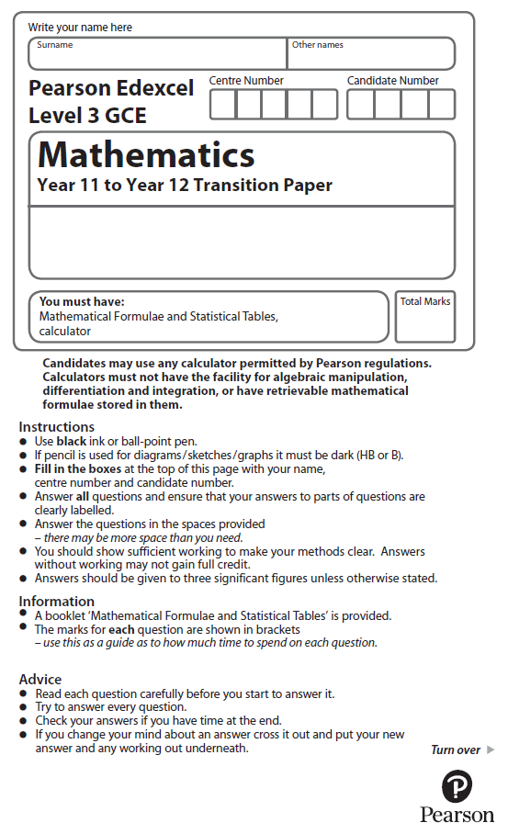
Quadratics

Calculators may NOT be used to answer these questions unless a symbol is shown next to the question.

1. (i) Show that x² – 8x + 17 > 0 for all real values of x
(3)
(ii) "If I add 3 to a number and square the sum, the result is greater than the square
of the original number."
State, giving a reason, if the above statement is always true, sometimes true or never true.
(2)
(Total for question 1 is 5 marks)

2. f (x) = x² – 10x + 23

(a) Express f (x) in the form (x + a )² + b, where a and b are constants to be found.
(2)
(b) Hence, or otherwise, find the exact solutions to the equation

x² – 10x + 23 = 0
(2)

(Total for Question 2 is 4 marks)

3. Factorise completely x − 4x³.
(3)

(Total for Question 3 is 3 marks)
4. The equation kx² + 4kx + 3 = 0, where k is a constant, has no real roots.
Prove that 0 ≤ k <
(4)

(Total for question 4 is 4 marks)
5. The curve C has equation
y = + 1 x ∈ ℝ, x ≠ 0
where k is a constant.
The line l has equation y = –2x + 5
(a) Show that the x coordinate of any point of intersection of l with C is given by a solution of the equation
2x² – 4x + k² = 0
(2)
(b) Hence find the exact values of k for which l is a tangent to C.
(3)
(Total for question 5 is 5 marks)

6. Find, using algebra, all real solutions to the equation b⁴ + 7b² – 18 = 0
(4)

(Total for question 6 is 4 marks)
7. A company started mining tin in Riverdale on 1st January 2019.
A model to find the total mass of tin that will be mined by the company in Riverdale is given by the equation
T = 1200 – 3(n – 20)²
where T tonnes is the total mass of tin mined in the n years after the start of mining.
Using this model,
(a) calculate the mass of tin that will be mined up to 1st January 2020,
(1)
(b) deduce the maximum total mass of tin that could be mined,
(1)
(c) calculate the mass of tin that will be mined in 2023.
(2)
(d) State, giving reasons, the limitation on the values of n.
(2)
(Total for question 7 is 6 marks)
8.
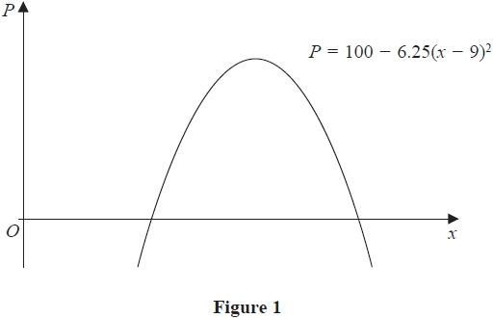
A company makes a particular type of children's toy.
The annual profit made by the company is modelled by the equation
P = 100 – 6.25(x – 9)²
where P is the profit measured in thousands of pounds and x is the selling price of the toy in pounds.
A sketch of P against x is shown in Figure 1.
Using the model,
(a) explain why £15 is not a sensible selling price for the toy.
(2)
Give that the company made an annual profit of more than £80 000
(b) find, according to the model, the least possible selling price for the toy.
(3)
The company wishes to maximise its annual profit.
State, according to the model,
(c) (i) the maximum possible annual profit,
(ii) the selling price of the toy that maximises the annual profit.
(2)
(Total for question 8 is 7 marks)

