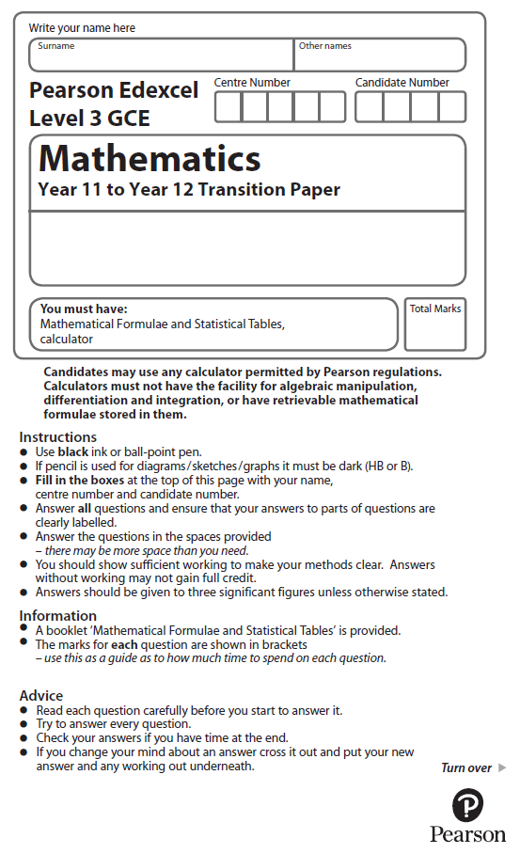

**Equations and Inequalities**

Calculator Icons - Free Download, PNG and SVG**Calculators may NOT be used to answer these questions unless a symbol is shown next to the question.**

**1.** On the grid, shade the region that satisfies all these inequalities.

|  |  |  |  |
| --- | --- | --- | --- |
| *x* > 0 | *y* > 0 | *y* > 3*x* – 6 | 2*x* + *y* < 12 |

Label the region **R**.



(Total for Question 1 is 4 marks)

**2.** Solve 6(2 – 3*x*) < 5(*x* + 1)

(Total for Question 2 is 3 marks)

**3.** (*a*) Solve  *x*2 ≥ 4*x* + 5

(3)

(*b*) For what range of values of *b* has the equation  25*x*2 + *bx* + 16 = 0  no real roots?

(2)

(Total for Question 3 is 5 marks)

**4.** (*a*)On the grid, shade the region that satisfies all these inequalities.

*x* < 3 *y* – *x* < 5 7*x* + 5*y* > 35

Label the region **R**

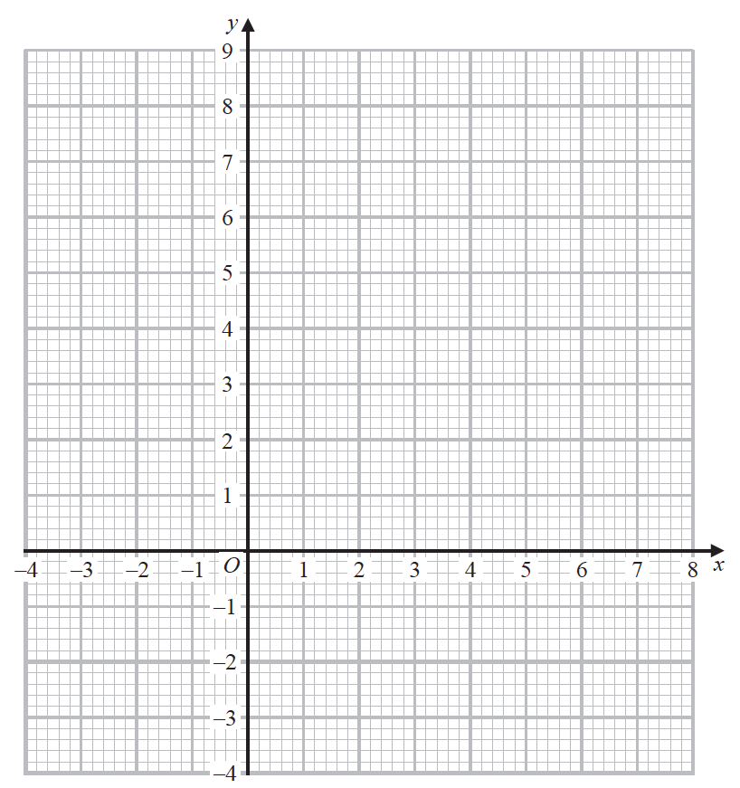

(5)

(*b*)Write down the coordinates of each of the points, with integer coordinates, that satisfy

*x* < 3 *y* – *x* < 5 7*x* + 5*y* > 35

(1)

(Total for Question 4 is 6 marks)

**5.** On the grid, shade the region that satisfies all these inequalities.

4*x* + 3*y* < 24 *x* > −2 3*y* > 9 − *x*

Label the region **R**.

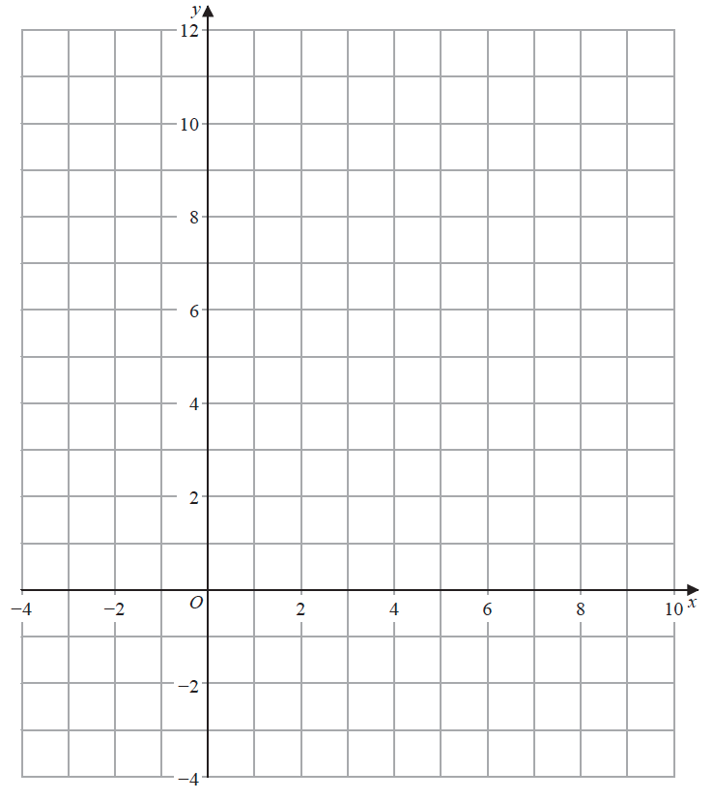

(Total for Question 5 is 5 marks)

**6.** Solve, algebraically, the simultaneous equations

2*x*2 + 2*y* = 7

2*y* + 2*x* = 3

(Total for Question 6 is 5 marks)

**7.** On the grid, shade the region that satisfies all these inequalities.

|  |  |  |
| --- | --- | --- |
| *x* > −1 | 2*x* + *y* < 6 | *y* < 4 − *x* |

Label the region **R**.

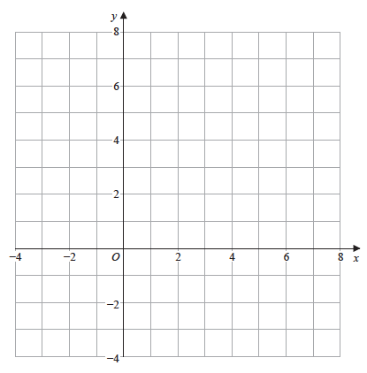

(Total for Question 7 is 5 marks)

**8.** Solve, algebraically, the simultaneous equations

2*x* + *y* = 7

4*x*2 + 3*y*2 = 43

(Total for Question 8 is 5 marks)

**9.** Solve the simultaneous equations

*y* – 2*x* – 4 = 0

4*x*2 + *y*2 + 20*x* = 0

(Total for Question 9 is 7 marks)

**10.** Solve the simultaneous equations

*y* + 4*x* + 1 = 0

*y*2 + 5*x*2 + 2*x* = 0

(Total for Question 10 is 6 marks)

**11.** Find the set of values of *x* for which

(*a*) 2(3*x* + 4) > 1 – *x*,

(2)

(*b*) 3*x*2 + 8*x* – 3 < 0.

(4)

(Total for Question 11 is 6 marks)

**12.** Find the set of values of *x* for which

(*a*) 4*x* − 5 **>** 15 − *x*,

(2)

(*b*) *x*(*x* − 4) **>** 12.

(4)

(Total for Question 12 is 6 marks)

**13.** Solve the simultaneous equations

*x* + *y* = 2

4*y*2 – *x*2 = 11

(Total for Question 13 is 7 marks)

**14.**The curve *C* has equation *y* = *x*(5 − *x*) and the line *L* has equation 2*y* = 5*x* + 4.

(*a*) Use algebra to show that *C* and *L* do not intersect.

(4)

(*b*) Sketch *C* and *L* on the same diagram, showing the coordinates of the points at which *C* and *L* meet the axes.

(4)

(Total for Question 14 is 8 marks)

Calculator Icons - Free Download, PNG and SVG**15.** (i) Show that *x*2 − 8*x* + 17 > 0 for all real values of *x.*

(3)

(ii) “If I add 3 to a number and square the sum, the result is greater than the square of the original number.”

State, giving a reason, if the above statement is always true, sometimes true or never true.

(2)

(Total for Question 15 is 5 marks)