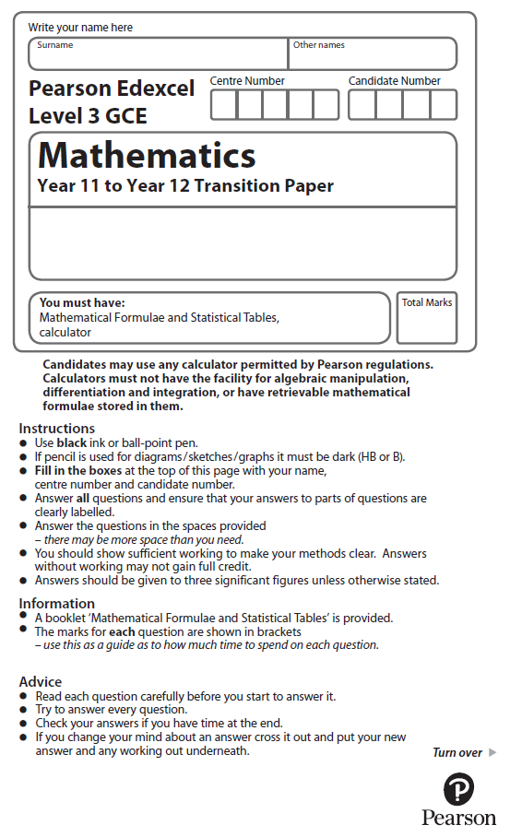

**Graphs and Transformations**

Calculator Icons - Free Download, PNG and SVG**Calculators may NOT be used to answer these questions unless a symbol is shown next to the question.**

**1.** Here are some sketch graphs.



The equation for one of these sketch graphs is *y* = 5 − *x*2 − 4*x*

Write down the letter of this sketch.

(Total for Question 1 is 1 mark)

**2.** Here is the graph of *y* = f(*x*)



(*a*)On the axes below, sketch the graph of *y* = − f(*x*)

On your sketch, show the coordinates of any points where the graph intersects the *x*-axis and show the coordinates of any turning points.



(2)

(*b*) On the axes below, sketch the graph of *y* = f(*x*)

On your sketch, show the coordinates of any points where the graph intersects the *x*-axis and show the coordinates of any turning points.



(2)

(Total for Question 2 is 4 marks)

**3.**



**Figure 1**

Figure 1 shows a sketch of part of the curve with equation *y* = f(*x*). The curve has a maximum point *A* at (–2, 4) and a minimum point *B* at (3, –8) and passes through the origin *O*.

On separate diagrams, sketch the curve with equation

(*a*) *y* = 3f(*x*),

(2)

(*b*) *y* = f(*x*) – 4.

(3)

On each diagram, show clearly the coordinates of the maximum and the minimum points and the coordinates of the point where the curve crosses the *y*-axis.

(Total for Question 3 is 5 marks)

**4.** (*a*) Factorise completely 9*x* – 4*x*3.

(3)

(*b*) Sketch the curve *C* with equation

*y* = 9*x* – 4*x*3.

Show on your sketch the coordinates at which the curve meets the *x*-axis.

(3)

The points *A* and *B* lie on *C* and have *x* coordinates of –2 and 1 respectively.

(*c*) Show that the length of *AB* is *k* √10, where *k* is a constant to be found.

(4)

(Total for Question 4 is 10 marks)

**5.**



**Figure 2**

Figure 2 shows a sketch of the curve with equation *y* = f(*x*) where

f(*x*) = (*x* + 3)2 (*x* – 1), *x* ∈ℝ.

The curve crosses the *x-*axis at (1, 0), touches it at (–3, 0) and crosses the *y-*axis

at (0, –9).

(*a*) Sketch the curve *C* with equation *y* = f(*x* + 2) and state the coordinates of the points where the curve *C* meets the *x-*axis.

(3)

(*b*) Write down an equation of the curve *C*.

(1)

(*c*) Use your answer to part (*b*) to find the coordinates of the point where the curve *C* meets the *y*-axis.

(2)

(Total for Question 5 is 6 marks)

**6.** f(*x*) = *x*2 – 8*x* + 19

(*a*)Express f(*x*) in the form (*x* + *a*)2 + *b*, where *a* and *b* are constants.

(2)

The curve *C* with equation *y* = f(*x*) crosses the *y*-axis at the point *P* and has a minimum point at the point *Q*.

(*b*)Sketch the graph of *C* showing the coordinates of point *P* and the coordinates of point *Q*.

(3)

(*c*)Find the distance *PQ*, writing your answer as a simplified surd.

(3)

(Total for Question 6 is 8 marks)

**7.**



**Figure 3**

Figure 3 shows a sketch of the curve *C* with equation

*y* =  + 1, *x* ≠ 0.

The curve *C* crosses the *x*-axis at the point *A.*

(*a*) State the *x-*coordinate of the point *A*.

(1)

The curve *D* has equation *y* = *x*2(*x* – 2), for all real values of *x*.

(*b*) On a copy of Figure 1, sketch a graph of curve *D*. Show the coordinates of each point where the curve *D* crosses the coordinate axes.

(3)

(*c*) Using your sketch, state, giving a reason, the number of real solutions to the equation

*x*2(*x* – 2) =  + 1.

(1)

(Total for Question 7 is 5 marks)

**8.**



**Figure 4**

Figure 4 shows a sketch of the curve *C* with equation *y* = f(*x*), where

f(*x*) = *x*2(9 – 2*x*).

There is a minimum at the origin, a maximum at the point (3, 27) and *C* cuts the *x*-axis at the point *A*.

(*a*) Write down the coordinates of the point *A*.

(1)

(*b*) On separate diagrams sketch the curve with equation

(i) *y* = f(*x* + 3),

(ii) *y* = f(3*x*).

On each sketch you should indicate clearly the coordinates of the maximum point and any points where the curves cross or meet the coordinate axes.

(6)

The curve with equation *y* = f(*x*) + *k*, where *k* is a constant, has a maximum point at (3, 10).

(*c*) Write down the value of *k*.

(1)

(Total for Question 8 is 8 marks)

9.



**Figure 5**

Figure 5 shows a sketch of the curve *C* with equation *y* = f(*x*).

The curve *C* passes through the origin and through (6, 0).

The curve *C* has a minimum at the point (3, –1).

On separate diagrams, sketch the curve with equation

(*a*) *y* = f(2*x*),

(3)

(*b*) *y* = −f(*x*),

(3)

(*c*) *y* = f(*x* + *p*), where *p* is a constant and 0 < *p* < 3.

(4)

On each diagram show the coordinates of any points where the curve intersects the *x*-axis and of any minimum or maximum points.

(Total for Question 9 is 10 marks)

**10.**



**Figure 6**

Figure 6 shows a sketch of the curve with equation *y* = , *x* ≠ 0.

The curve *C* has equation *y* = − 5, *x* ≠ 0, and the line *l* has equation *y* = 4*x* + 2.

(*a*) Sketch and clearly label the graphs of *C* and *l* on a single diagram.

On your diagram, show clearly the coordinates of the points where *C* and *l* cross the coordinate axes.

(5)

(*b*) Write down the equations of the asymptotes of the curve *C*.

(2)

(*c*) Find the coordinates of the points of intersection of *y* = − 5 and *y* = 4*x* + 2.

(5)

(Total for Question 10 is 12 marks)

**11.** (*a*)On separate axes sketch the graphs of

(i) *y* = –3*x* + *c*, where *c* is a positive constant,

(ii) 

On each sketch show the coordinates of any point at which the graph crosses the

*y*-axis and the equation of any horizontal asymptote.

(4)

Given that *y* = –3*x* + *c*, where *c* is a positive constant, meets the curve at two distinct points,

(*b*)show that (5 – *c*)2 > 12

(3)

(*c*)Hence find the range of possible values for *c*.

(4)

(Total for Question 11 is 11 marks)

**12*.*** The curve *C* has equation *y* = *x*(5 − *x*) and the line *L* has equation 2*y* = 5*x* + 4.

(*a*) Use algebra to show that *C* and *L* do not intersect.

(4)

(*b*) Sketch *C* and *L* on the same diagram, showing the coordinates of the points at which *C* and *L* meet the axes.

(4)

(Total for Question 12 is 8 marks)

**13.**

**Figure 7**

Figure 7 shows a sketch of the curve with equation *y* = f(*x*) where



The curve passes through the origin and touches the *x*-axis at the point (3, 0).

There is a maximum point at (1,4) and a minimum point at (3,0).

(*a*)On separate diagrams, sketch the curve with equation

(i),

(ii) *y* = f(*x* + 2).

On each sketch indicate clearly the coordinates of

* any points where the curve crosses or touches the *x*-axis,
* the point where the curve crosses the *y*-axis,
* any maximum or minimum points.

(6)

The curve with equation *y* = f (*x*) + *k*, where *k* is a non-zero constant, has a maximum point at (*a*, 0).

(*b*)Write down the values of *a* and *k*.

(2)

(Total for Question 13 is 8 marks)

****14.**

**Figure 8**

Figure 8 shows the sketch of a curve with equation *y* = f (*x*), *x* ∈ ℝ.

The curve crosses the *y*-axis at (0, 4) and crosses the *x*-axis at (5, 0).

The curve has a single turning point, a maximum, at (2, 7).

The line with equation *y* = 1 is the only asymptote to the curve.

(*a*) State the coordinates of the turning point on the curve with equation

*y* = f (*x* – 2).

(1)

(*b*)State the solution of the equation f (2*x*) = 0

(1)

(*c*)State the equation of the asymptote to the curve with equation *y* = f (–*x*).

(1)

Given that the line with equation *y* = *k*, where *k* is a constant, meets the curve

*y* = f (*x*) at only one point,

(*d*)state the set of possible values for *k*.

(2)

(Total for Question 14 is 5 marks)

Calculator Icons - Free Download, PNG and SVG**15.**

**

**Figure 9**

Figure 9 shows a sketch of the curve with equation *y* = g(*x*).

The curve has a single turning point, a minimum, at the point *M*(4, –1.5).

The curve crosses the *x*-axis at two points, *P*(2, 0) and *Q*(7, 0).

The curve crosses the *y*-axis at a single point *R*(0, 5).

(*a*) State the coordinates of the turning point on the curve with equation *y* = 2g(*x*).

(1)

(*b*) State the largest root of the equation g(*x* + 1) = 0.

(1)

(*c*) State the range of values of *x* for which g′(*x*) ≤ 0.

(1)

Given that the equation g(*x*) + *k* = 0, where *k* is a constant, has no real roots,

(*d*) state the range of possible values for *k*.

(1)

(Total for Question 15 is 4 marks)