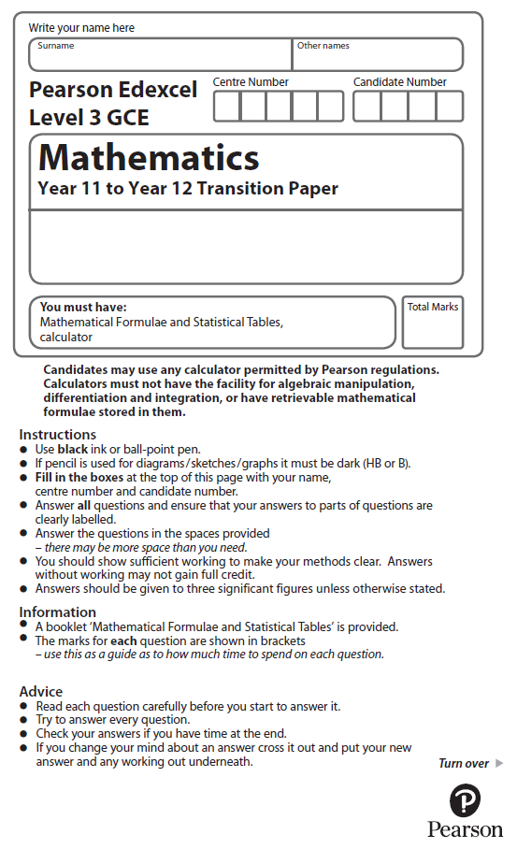

**Circles**

Calculator Icons - Free Download, PNG and SVG**You may use a calculator to answer these questions.**

**1.** The equation of circle **C** is *x*2 + *y*2 = 16

The circle **C** is translated by the vector  to give circle **B**.

Draw a sketch of circle **B**.

Label with coordinates the centre of circle **B** and any points of intersection with the

*x*-axis.

(Total for Question 1 is 3 marks)

**2.**



**Figure 1**

The circle *C* has centre *P*(7, 8) and passes through the point *Q*(10, 13), as shown in Figure 1.

(*a*)Find the length *PQ*, giving your answer as an exact value.

(2)

(*b*)Hence write down an equation for *C*.

(2)

The line *l* is a tangent to *C* at the point *Q*, as shown in Figure 2.

(*c*)Find an equation for *l*, giving your answer in the form *ax* + *by* + *c* = 0, where *a*, *b* and are integers.

(4)

(Total for Question 2 is 8 marks)

**3.** The circle *C* has equation

*x*2 + *y*2 − 2*x* + 14*y* = 0

Find

(*a*)the coordinates of the centre of *C*,

(2)

(*b*)the exact value of the radius of *C*,

(2)

(*c*)the *y* coordinates of the points where the circle *C* crosses the *y*-axis.

(2)

(*d*)Find an equation of the tangent to *C* at the point (2, 0), giving your answer in the form *ax* + *by* + *c* = 0, where *a*, *b* and *c* are integers.

(4)

(Total for Question 3 is 10 marks)

**4.** The circle *C* has equation

*x*2 + *y*2 – 10*x* + 6*y* + 30 = 0

Find

(*a*)the coordinates of the centre of *C*,

(2)

(*b*)the radius of *C*,

(2)

(*c*)the *y* coordinates of the points where the circle *C* crosses the line with equation *x* = 4,

giving your answers as simplified surds.

(3)

(Total for Question 4 is 7 marks)

**5.** A circle *C* has centre (−1, 7) and passes through the point (0, 0).

Find an equation for *C*.

(Total for Question 5 is 4 marks)

**6.** A circle *C* with centre at the point (2, –1) passes through the point *A* at (4, –5).

(*a*) Find an equation for the circle *C*.

(3)

(*b*) Find an equation of the tangent to the circle *C* at the point *A*, giving your answer in the form *ax* + *by* + *c* = 0, where *a*, *b* and *c* are integers*.*

(4)

(Total for Question 6 is 7 marks)

**7*.***The circle *C* has equation

*x*2 + *y*2 − 20*x* − 24*y* + 195 = 0.

The centre of *C* is at the point *M*.

(*a*) Find

(i) the coordinates of the point *M*,

(ii) the radius of the circle *C*.

(5)

*N* is the point with coordinates (25, 32).

(*b*) Find the length of the line *MN*.

(2)

The tangent to *C* at a point *P* on the circle passes through point *N*.

(*c*) Find the length of the line *NP*.

(2)

(Total for Question 7 is 9 marks)

**8.** The points *A* and *B* have coordinates (–2, 11) and (8, 1) respectively.

Given that *AB* is a diameter of the circle *C*,

(*a*) show that the centre of *C* has coordinates (3, 6),

(1)

(i) find an equation for *C*.

(4)

(*c*) Verify that the point (10, 7) lies on *C*.

(1)

(*d*) Find an equation of the tangent to *C* at the point (10, 7), giving your answer in the form *y*= *mx* + *c*, where *m* and *c* are constants.

(4)

(Total for Question 7 is 10 marks)

**9.**



**Figure 2**

The circle *C* with centre *T* and radius *r* has equation

*x*2 + *y*2 – 20*x* – 16*y* + 139 = 0.

(*a*) Find the coordinates of the centre of *C*.

(3)

(*b*) Show that *r* = 5

(2)

The line *L* has equation *x* = 13 and crosses *C* at the points *P* and *Q* as shown in Figure 1.

(*c*) Find the *y* coordinate of *P* and the *y* coordinate of *Q*.

(3)

(Total for Question 9 is 8 marks)

**10.** A circle *C* has equation

*x*2 + *y*2 – 4*x* + 8*y* – 8 = 0

(*a*)Find

(i) the coordinates of the centre of *C*,

(ii) the exact radius of *C*.

(3)

The straight line with equation *x* = *k*, where *k* is a constant, is a tangent to *C*.

(*b*)Find the possible values for *k*.

(2)

(Total for Question 10 is 5 marks)

**11.** The circle *C* has equation

*x*2 + *y*2 + 4*x* − 2*y* −11 = 0.

Find

(*a*) the coordinates of the centre of *C*,

(2)

(*b*) the radius of *C*,

(2)

(*c*) the coordinates of the points where *C* crosses the *y*-axis, giving your answers as simplified surds.

(4)

(Total for Question 11 is 8 marks)

**12.**



**Figure 3**

Figure 3 shows a circle *C* with centre *Q* and radius 4 and the point *T* which lies on *C*. The tangent to *C* at the point *T* passes through the origin *O* and *OT* = 6√5.

Given that the coordinates of *Q* are (11, *k*), where *k* is a positive constant,

(a*) find the exact value of k,*

(3)

(*b*) find an equation for *C*.

(2)

(Total for Question 12 is 5 marks)

**13.**



**Figure 4**

The circle *C* has radius 5 and touches the *y*-axis at the point (0, 9), as shown in Figure 4.

(*a*) Write down an equation for the circle *C*, that is shown in Figure 4.

(3)

A line through the point *P*(8, –7) is a tangent to the circle *C* at the point *T*.

(*b*) Find the length of *PT*.

(3)

(Total for Question 13 is 6 marks)

**14**. A circle C with centre at (−2, 6) passes through the point (10, 11).

(*a*) Show that the circle *C* also passes through the point (10, 1).

(3)

The tangent to the circle C at the point (10, 11) meets the *y*-axis at the point *P*  
and the tangent to the circle *C* at the point (10, 1) meets the *y*-axis at the point *Q*.

(*b*) Show that the distance *PQ* is 58, explaining your method clearly.

(7)

(Total for Question 14 is 10 marks)

**15.** A circle *C* has centre (2, 5). Given that the point *P*(–2, 3) lies on *C*.

(*a*) find an equation for *C*.

(3)

The line *l* is the tangent to *C* at the point *P*. The point *Q*(2, *k*) lies on *l*.

(*b*) Find the value of *k*.

(5)

(Total for Question 15 is 8 marks)

**16.** The circle *C* has equation

*x*2 + *y*2 − 6*x* + 10*y* + 9 = 0.

(*a*) Find

(i) the coordinates of the centre of *C*,

(ii) the radius of *C*.

(3)

The line with equation *y* = *kx*, where *k* is a constant, cuts *C* at two distinct points.

(*b*) Find the range of values for *k*.

(6)

(Total for Question 16 is 9 marks)