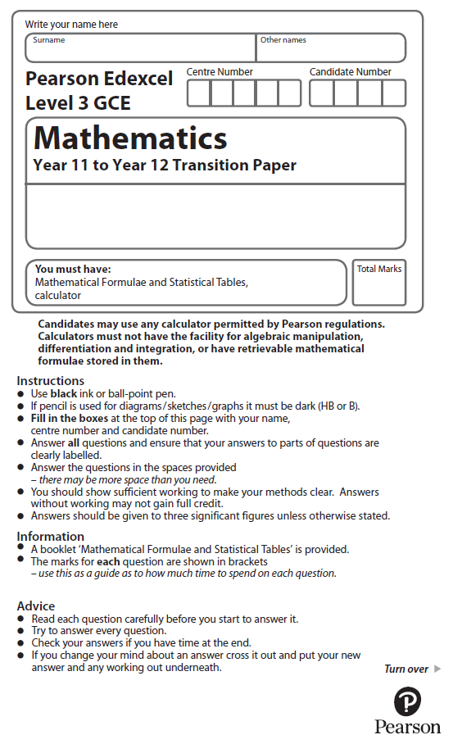

**Algebraic Methods**

Calculator Icons - Free Download, PNG and SVG**Calculators may NOT be used to answer these questions unless a symbol is shown next to the question.**

**1.** Simplify 

(Total for Question 1 is 2 marks)

**2.** Express  as a single fraction.

Give your answer in its simplest form.

(Total for Question 2 is 3 marks)

**3.** Write  as a single fraction.

Give your answer in its simplest form.

(Total for Question 3 is 3 marks)

**4.** Simplify fully 

(Total for Question 4 is 2 marks)

**5.** Simplify 

(Total for Question 5 is 3 marks)

**6.**Simplify 

(Total for Question 6 is 2 marks)

**7.** Write  as a single fraction.

Give your answer in its simplest form.

(Total for Question 7 is 3 marks)

**8.** Simplify fully 

(Total for Question 8 is 3 marks)

**9.** Express  as a single fraction.

Give your answer in its simplest form.

(Total for Question 9 is 3 marks)

**10.** Simplify 

(Total for Question 10 is 2 marks)

**11.** Write  as a single fraction.

Give your answer in its simplest form.

(Total for Question 11 is 4 marks)

**12.** Simplify 

(Total for Question 12 is 3 marks)

**13.** Simplify 

(Total for Question 15 is 2 marks)

**14.** Simplify fully 

(Total for Question 14 is 4 marks)

Calculator Icons - Free Download, PNG and SVG**15.** Show that can be written in the form *A* + **, where *A* and *B* are integers to be found.

(Total for Question 13 is 3 marks)