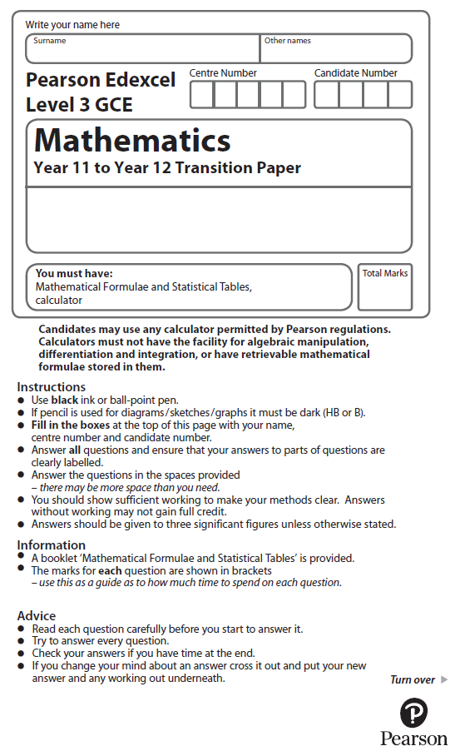

**Trigonometric Ratios**

Calculator Icons - Free Download, PNG and SVG**Calculators may NOT be used to answer these questions unless a symbol is shown next to the question.**

**1.** Here is a right-angled triangle.

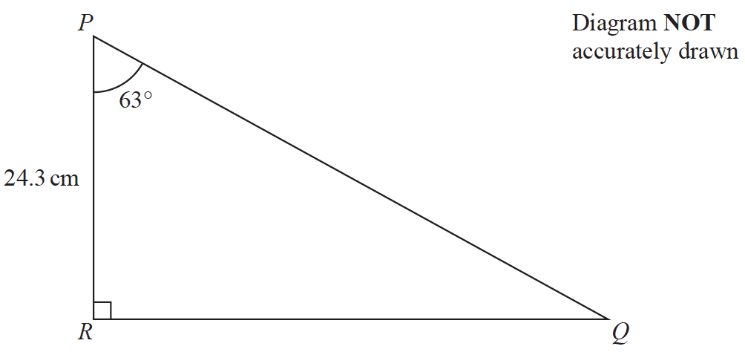

Calculate the length of *PQ*.

Give your answer correct to 3 significant figures.

(Total for Question 1 is 3 marks)

Calculator Icons - Free Download, PNG and SVG**2.**

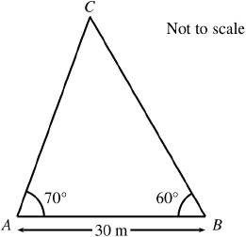

**Figure 1**

A triangular lawn is modelled by the triangle *ABC*, shown in Figure 1. The length *AB* is to be 30 m long.

Given that angle *BAC* = 70° and angle *ABC* = 60°,

(*a*) calculate the area of the lawn to 3 significant figures.

(4)

(*b*) Why is your answer unlikely to be accurate to the nearest square metre?

(1)

 (Total for Question 2 is 5 marks)

Calculator Icons - Free Download, PNG and SVG**3.**

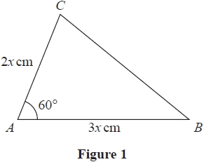

**Figure 2**

Figure 2 shows a sketch of a triangle *ABC* with *AB* = 3*x* cm, *AC* = 2*x* cm and   
angle *CAB* = 60°

Given that the area of triangle *ABC* is  cm2

(*a*) show that *x* =

(3)

(*b*) Hence find the exact length of *BC*, giving your answer as a simplified surd.

(3)

 (Total for Question 3 is 6 marks)

Calculator Icons - Free Download, PNG and SVG**4.** *ABCD* is a quadrilateral.

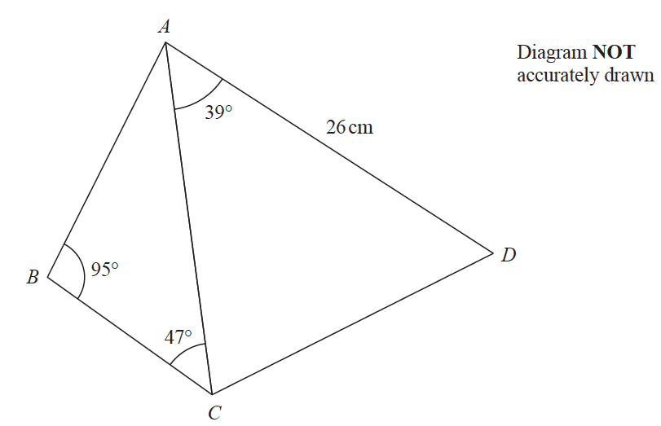

The area of triangle *ACD* is 250 cm2

Calculate the area of the quadrilateral *ABCD*.

Show your working clearly.

Give your answer correct to 3 significant figures.

(Total for Question 4 is 6 marks)

**5.** Here is triangle *ABC*.



Calculate the value of *x*.

Give your answer correct to 3 significant figures.

(Total for Question 5 is 5 marks)

Calculator Icons - Free Download, PNG and SVG

**6.**

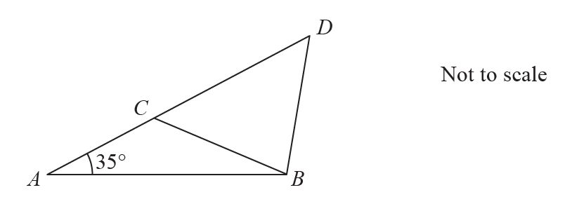

**Figure 3**

Figure 3 shows the design for a structure used to support a roof.

The structure consists of four wooden beams, *AB*, *BD*, *BC* and *AD*.

Given *AB* = 6.5 m, *BC* = *BD* = 4.7 m and angle *BAC* = 35°

(*a*) find, to one decimal place, the size of angle *ACB*,

(3)

(*b*) find, to the nearest metre, the total length of wood required to make this structure.

(3)

(Total for Question 6 is 6 marks)

Calculator Icons - Free Download, PNG and SVG**7.** A parallelogram *ABCD* has area 40 cm2

Given that *AB* has length 10 cm, *BC* has length 6 cm and angle *DAB* is obtuse, find

(*a*)the size of angle *DAB*, in degrees, to 2 decimal places,

(3)

(*b*)the length of diagonal *BD*, in cm, to one decimal place.

(2)

(Total for Question 7 is 5 marks)

Calculator Icons - Free Download, PNG and SVG

**8.**



**Figure 4**

Figure 4 shows a sketch of the curve *C* with equation *y* = sin(*x* – 60°), –360° ≤ *x* ≤ 360°.

(*a*) Write down the exact coordinates of the points at which *C* meets the two coordinate axes.

(3)

(*b*) Solve, for –360° ≤ *x* ≤ 360°,

4 sin(*x* – 60°) = √6 − √2

showing each stage of your working.

(5)

(Total for Question 8 is 8 marks)

Calculator Icons - Free Download, PNG and SVG**9.**

**

**Figure 5**

Figure 5 shows a sketch of a triangle *ABC*.

Given that *AB* = 4*x* , *BC* = 3*x* and angle *BAC* = 30°

(*a*)show that sin *ACB* = 

(2)

Given that angle *ACB* is obtuse,

(*b*)find the size of angle *ABC*, giving your answer in degrees, to 2 decimal places.

(2)

Given further that the area of triangle *ABC* is 20

(*c*)find the value of *x* to 2 decimal places,

(3)

(*d*)find the length of side *AC* to 2 decimal places.

(2)

(Total for Question 9 is 9 marks)

Calculator Icons - Free Download, PNG and SVG**10**. In a triangle ABC, side AB has length 10 cm, side AC has length 5 cm, and angle BAC = θ where θ is measured in degrees. The area of triangle ABC is 15cm2

(*a*)  Find the two possible values of cos *θ*

(4)

Given that *BC* is the longest side of the triangle,

(*b*)  find the exact length of *BC*.

(2)

 (Total for Question 10 is 6 marks)