**Matching Cards**

**Master 51a**

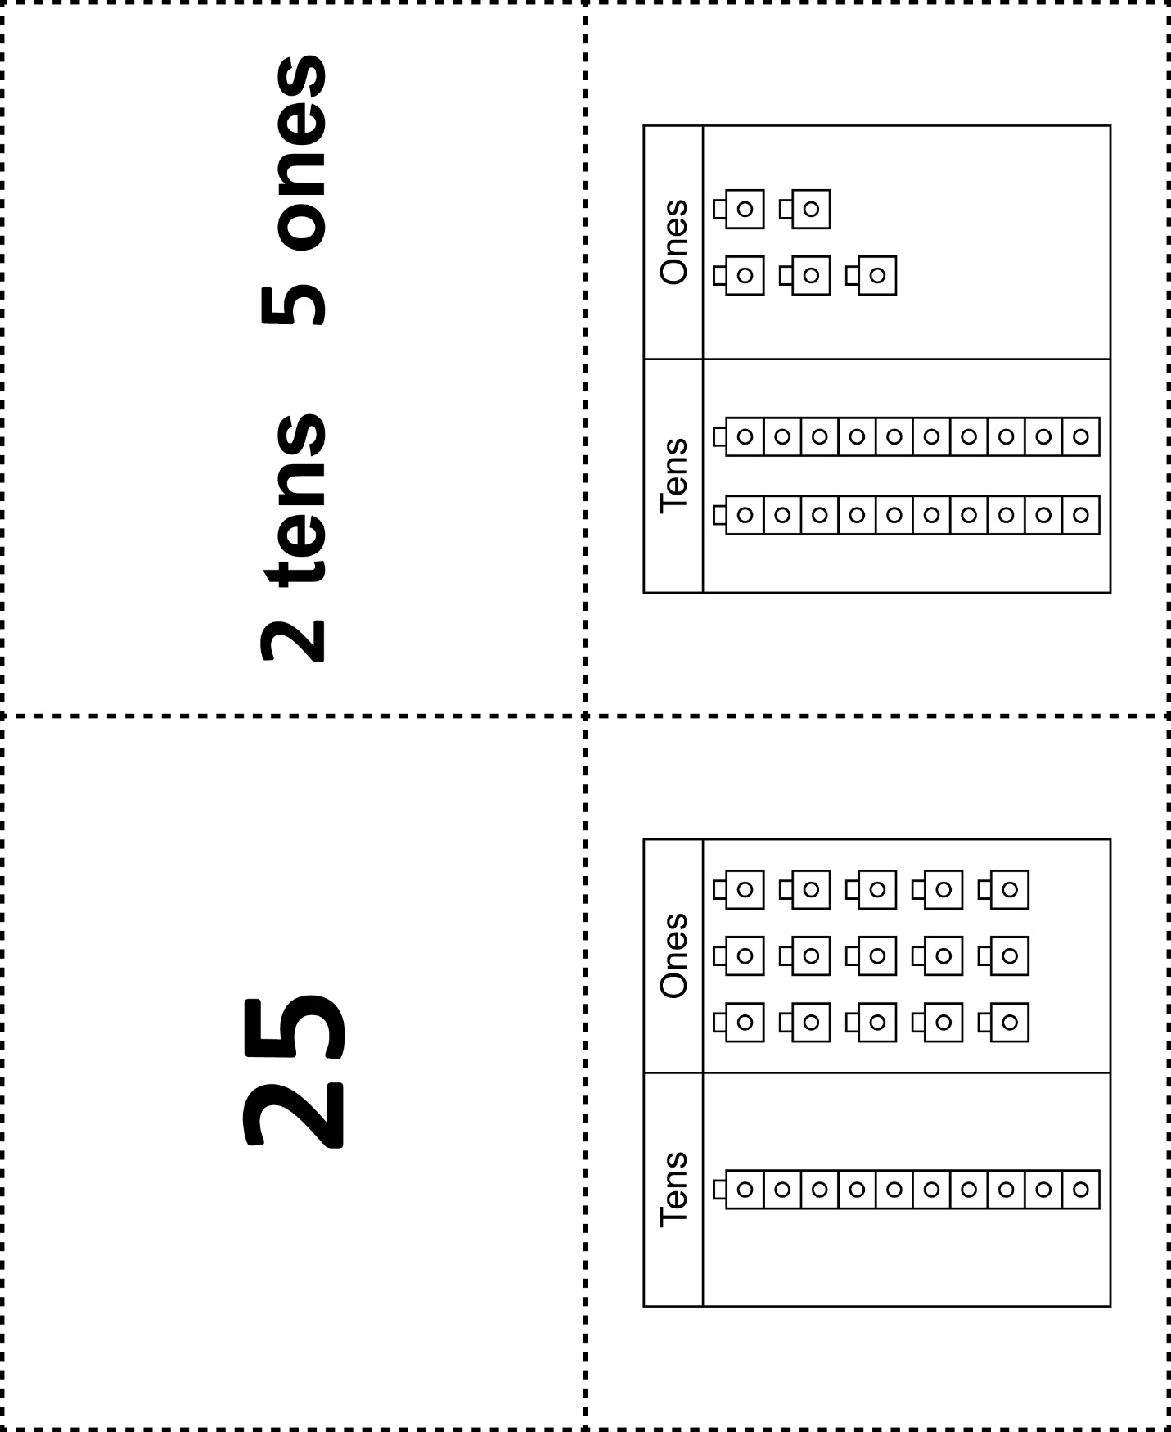



**Matching Cards**

**Master 51b**

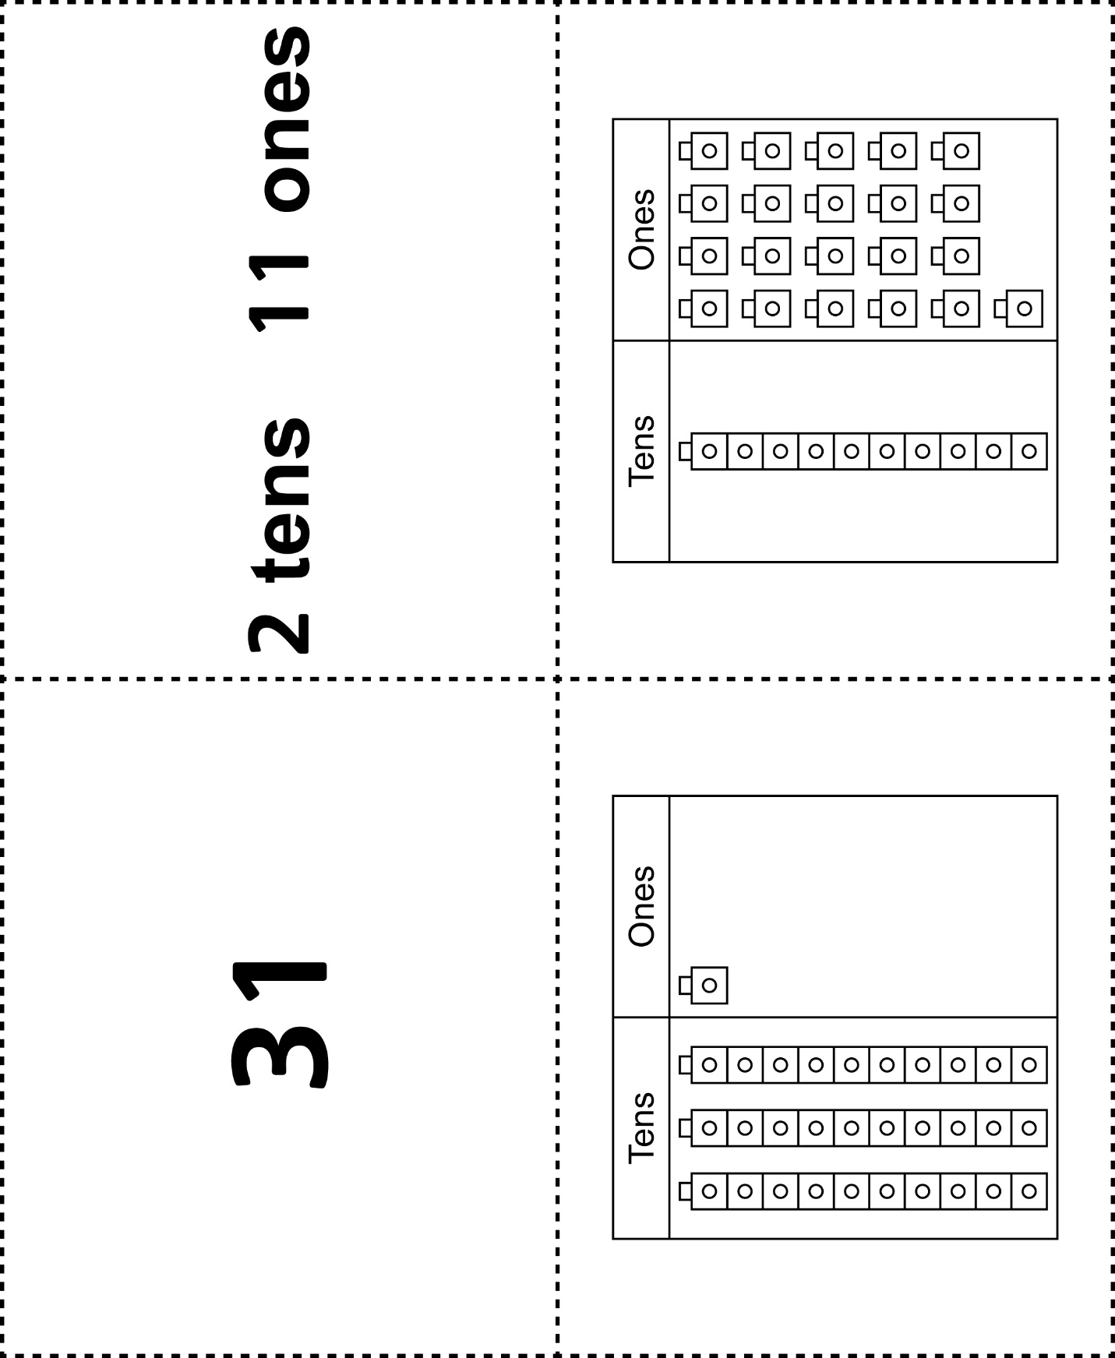

**Matching Cards**

**Master 51c**



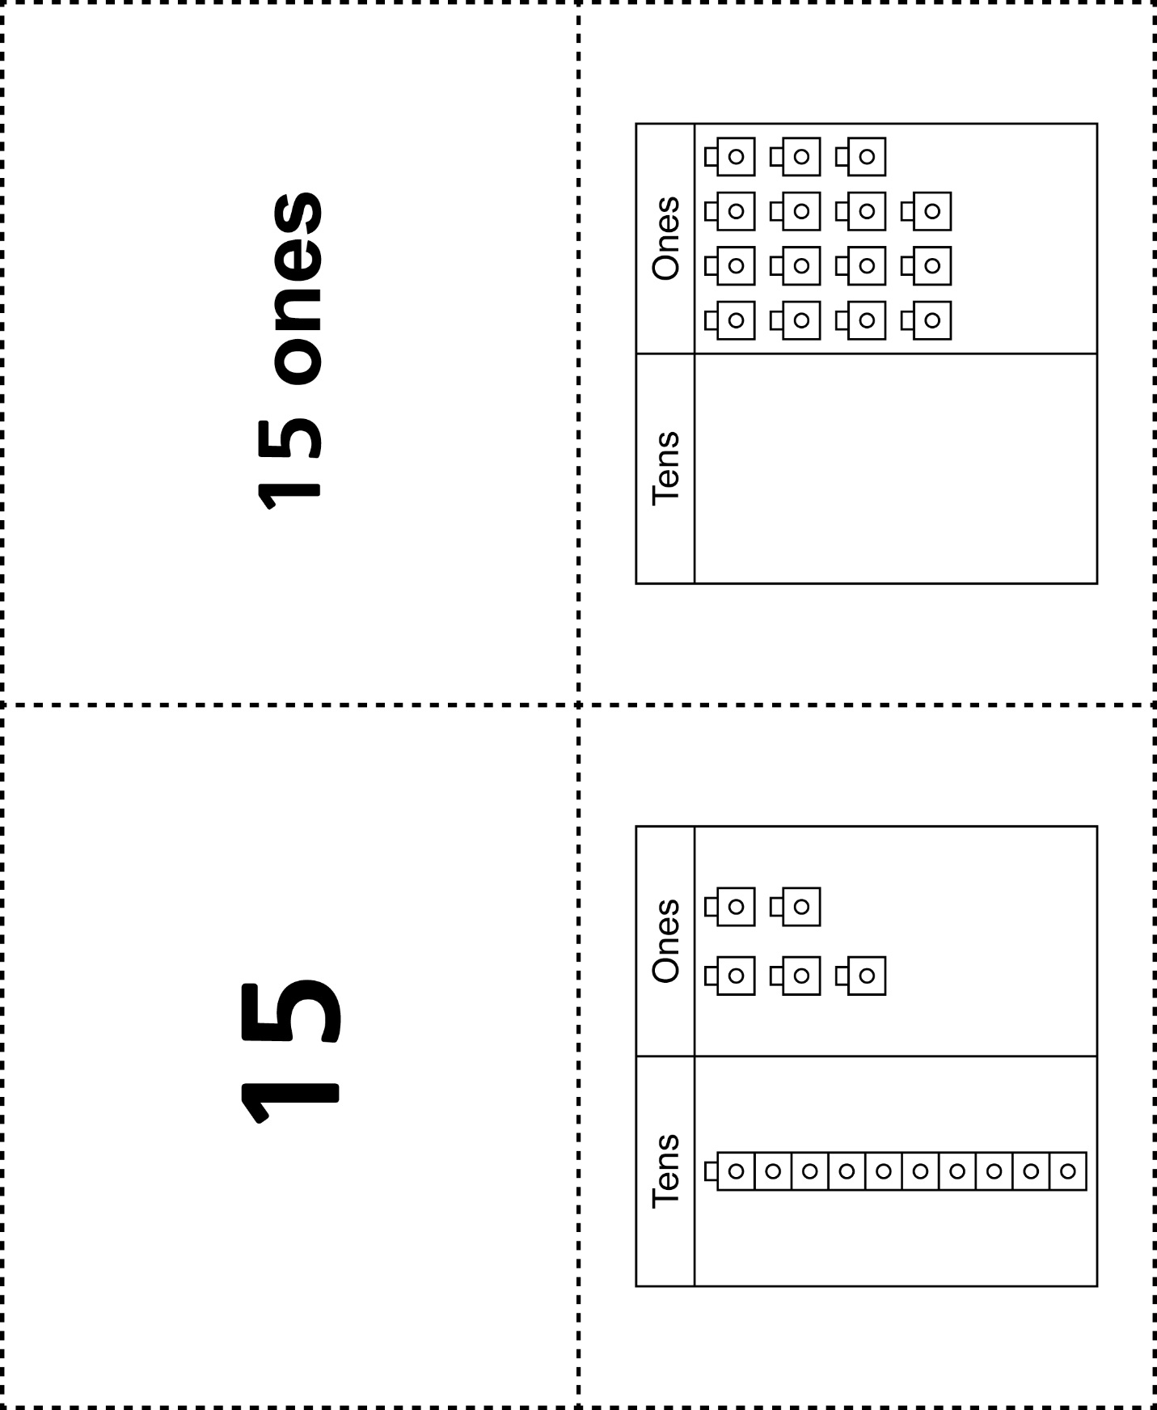

**Matching Cards**

**Master 51d**

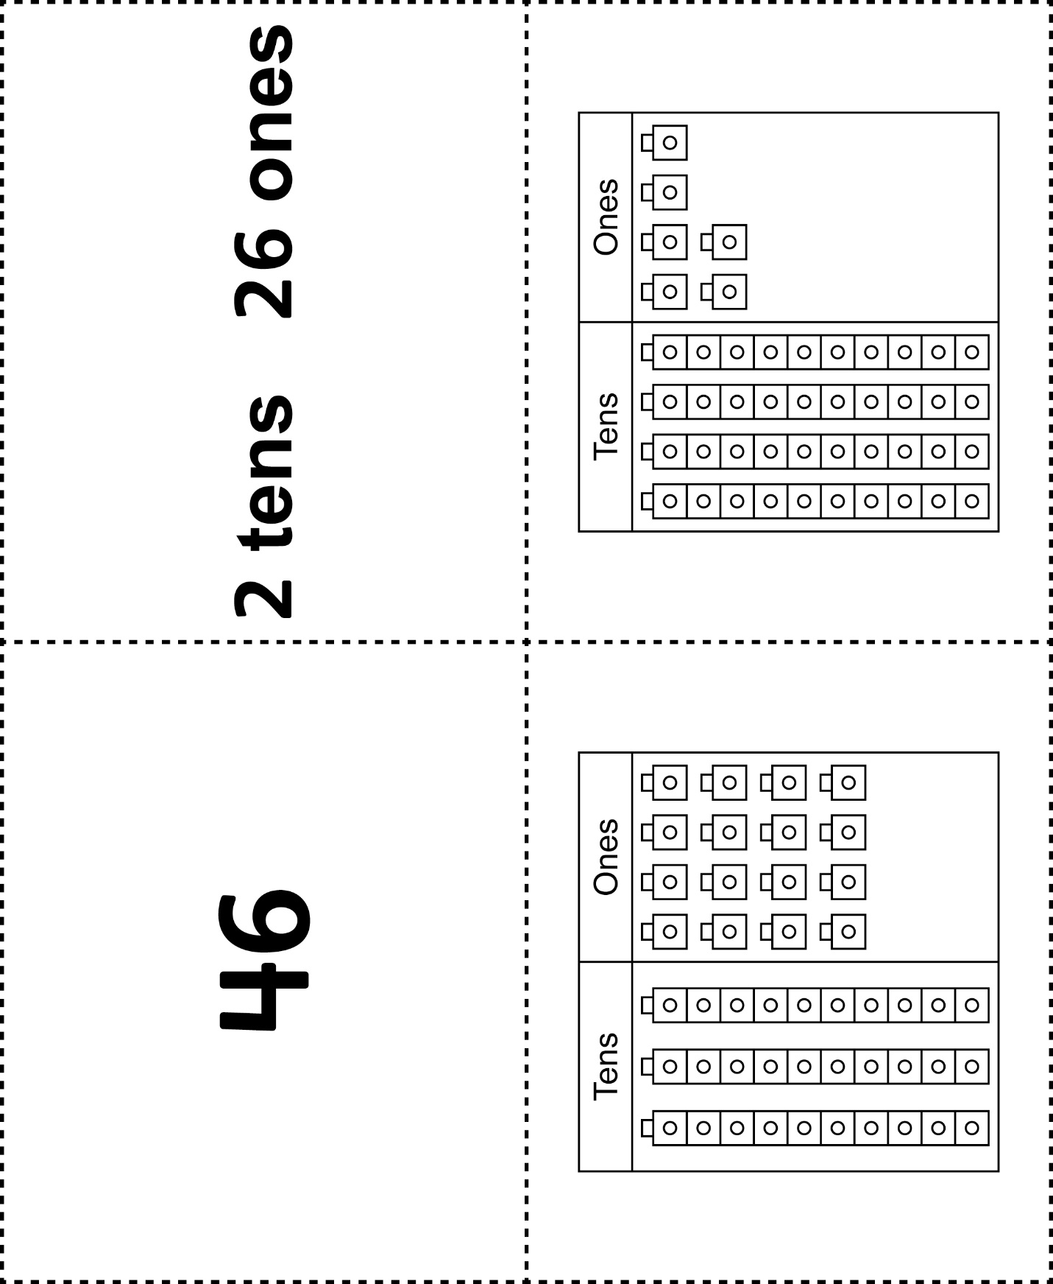



**Matching Cards**

**Master 51e**

|  |  |
| --- | --- |
|  |  |
|  |  |

