**Common Doubles**

**Master 71a**

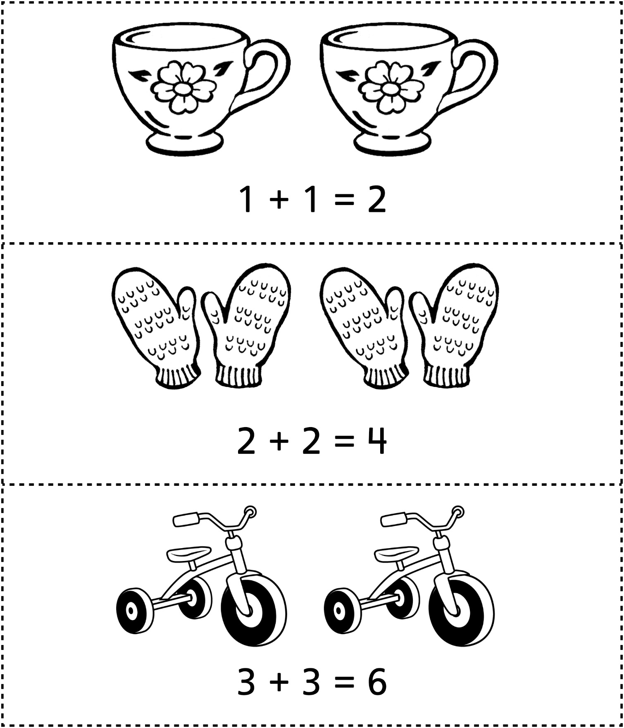

**Common Doubles**

**Master 71b**

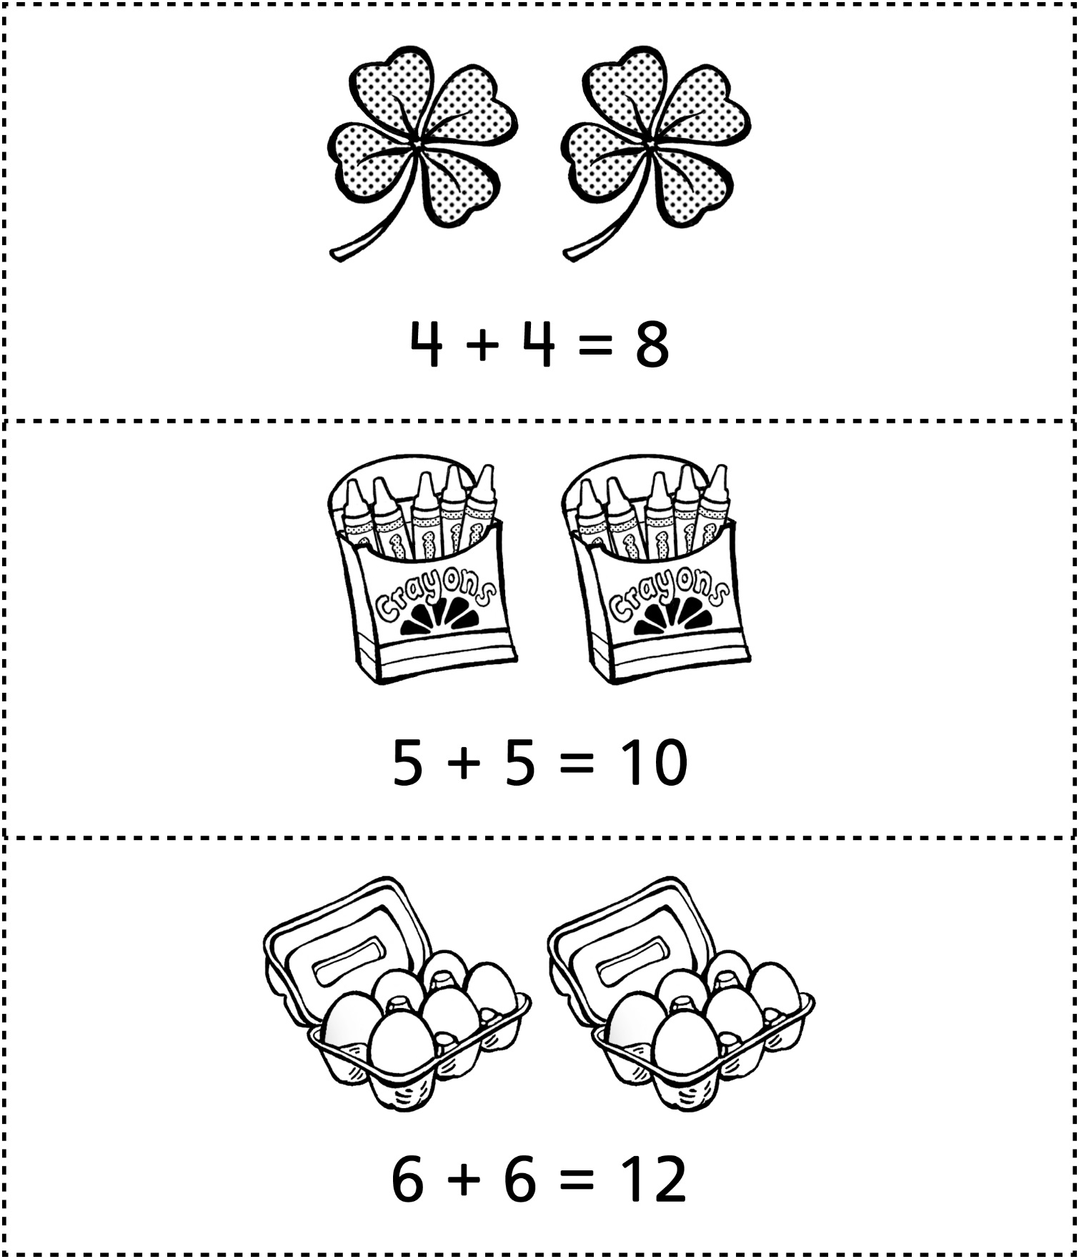

**Common Doubles**

**Master 71c**

