**Object Pictures**

**Master 99a**

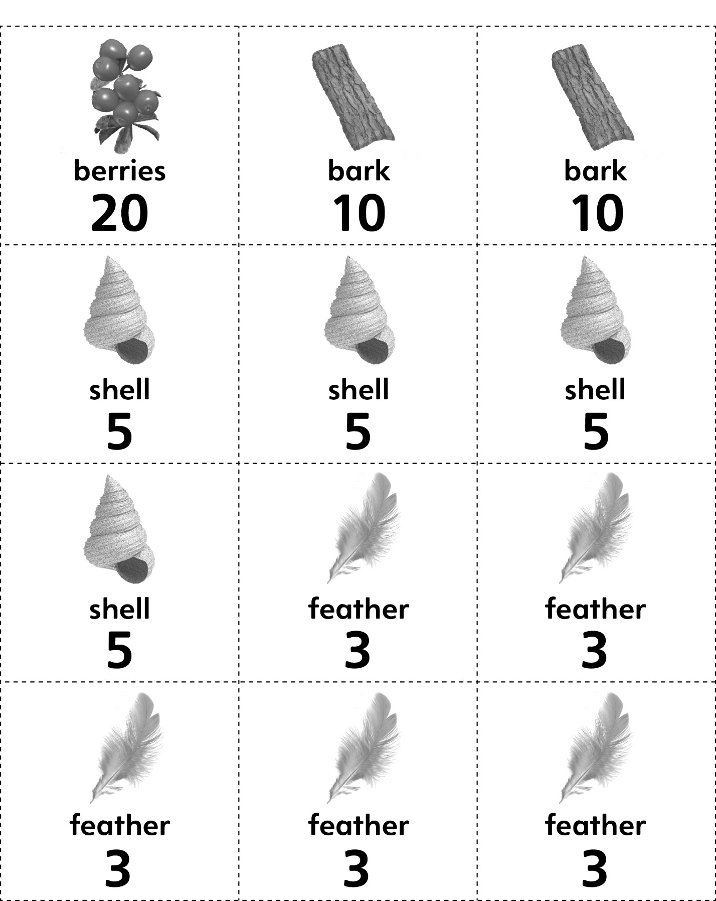



**Object Pictures**

**Master 99b**



