Sorting Shapes and Identifying Sorting Rules Behaviours/Strategies
Student is unable to identify a shape with its mathematical name.  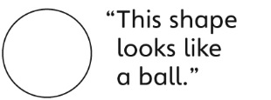 | Student identifies shapes but is unable to explain how two shapes are alike and how they are different, and makes random guesses. | 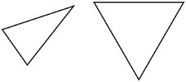  Student sorts by appearance rather than attributes, and does not realize that the orientation of a shape does not matter.
Observations/Documentation
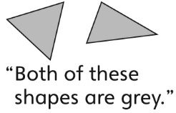  Student focuses only on non-geometric attributes (e.g., colour) instead of geometric attributes (e.g., number of sides). | Student sorts shapes using common attributes, but struggles to communicate the sorting rule. | Student sorts shapes using common attributes and uses mathematical language to communicate the sorting rule.
Observations/Documentation

