Sorting Solids Behaviours/Strategies
Student is unable to select a solid based on the needed attribute. | 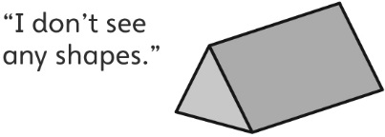  Student focuses on one shape and doesn’t realize that more than one shape can be a face of a solid. | Student can sort solids with ease.
Observations/Documentation
Building Towers Behaviours/Strategies
Student builds tower but doesn't use all the solids chosen according to the spinner's rules. Student only includes the solids that have square or rectangular faces. | Student builds a tower with all the chosen solids, but makes an incomplete list of the shapes in the tower's faces. | Student builds a tower with all the chosen solids and identifies the shapes in the tower's faces with ease.
Observations/Documentation

