Reading and Writing Codes Behaviours/Strategies
- Student describes the movement from one  location to another on a grid, but struggles to  write it as a code.  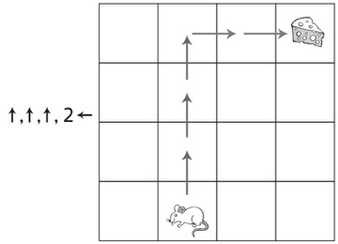 | - Student describes the movement from one  location to another on a grid and writes code,  but makes perspective errors.  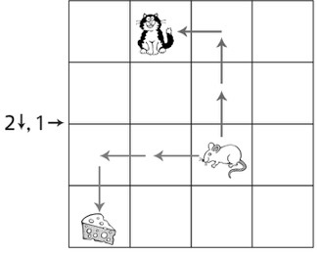 | - Student describes the movement from one  location to another on a grid and writes code  that is accurate in direction, but not in quantity.  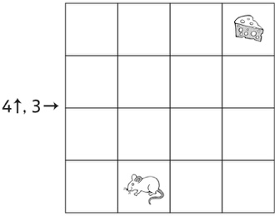
Observations/Documentation
- Student describes the movement from one  location to another on a grid and writes accurate code, but starts over to make a code to avoid the cat. | - Student describes the movement from one  location to another on a grid and writes accurate code, but makes errors in where or how to adjust the code. | - Student describes the movement from one  location to another on a grid, reads and writes  code, and accurately adjusts code to avoid cats.
Observations/Documentation

