Activity Recording Sheets
Master 63a

Part A: Decomposition
- Represent your number in at least
3 different ways.
- Draw a picture to show each way.

Our Number

Activity Recording Sheets
Master 63b

Part B: Equal Shares
- Place the cards face down in a pile. Turn over a card.
- Use a drawing to share equally between 2 people.
How much does each person get?

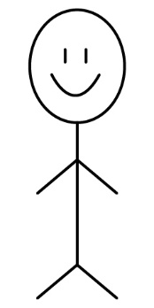

- Repeat, this time sharing the number among 4 people.

Activity Recording Sheets
Master 63c

Part C: Solving an Equal-Grouping Problem
Some students share 5 celery stalks equally.
Each student received half of a celery stalk.
How many students were there in the group?
Draw a picture to solve the problem.

