Fish Weirs Story
Master 83

By Pam Spooner and Colin Williams

Most First Nations people know a lot about the different fish species in the waters of their land. Nations who fish in the same river are only allowed to catch a certain number of fish.
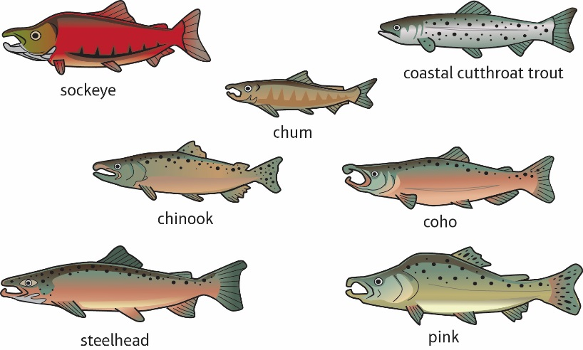

It is very important to protect the salmon populations. We must take care of the environment so the salmon survive, as many people in the world eat salmon.

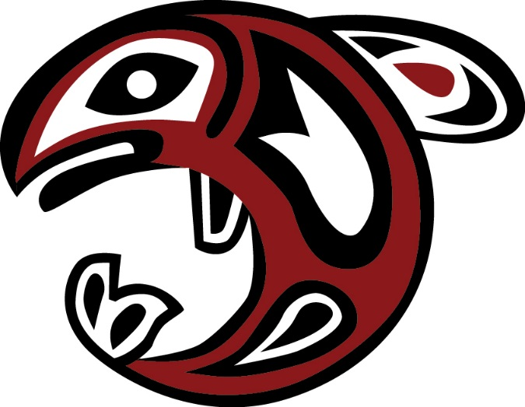

A weir acts as a fence across a river to trap fish. First Nations people use stones, large rocks, and wood to build weirs.

Men would travel down the river in canoes and others would walk on the shore beside the canoes. Traps full of fish would then be lifted out of the toh’ (water).

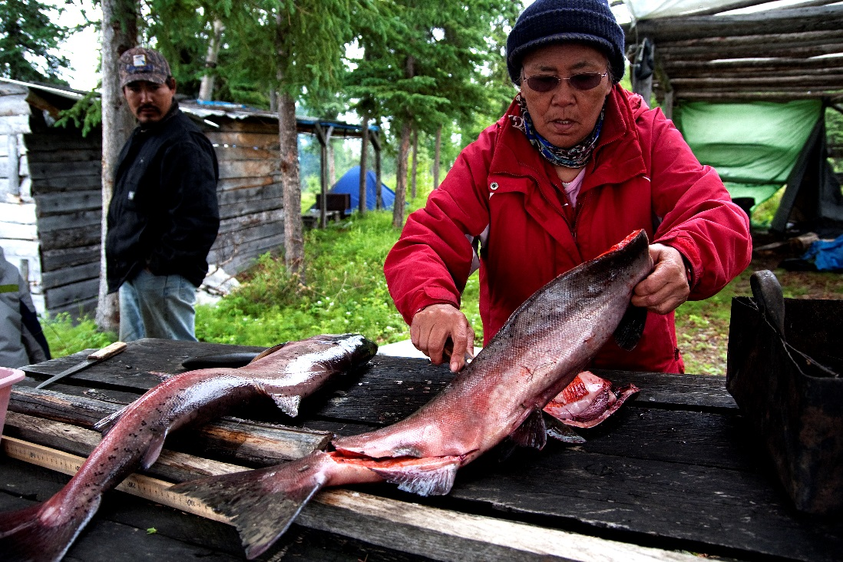
The fish would be brought to the shore, where Ts’oh (grandma) and her children would clean the Th’lok (fish).

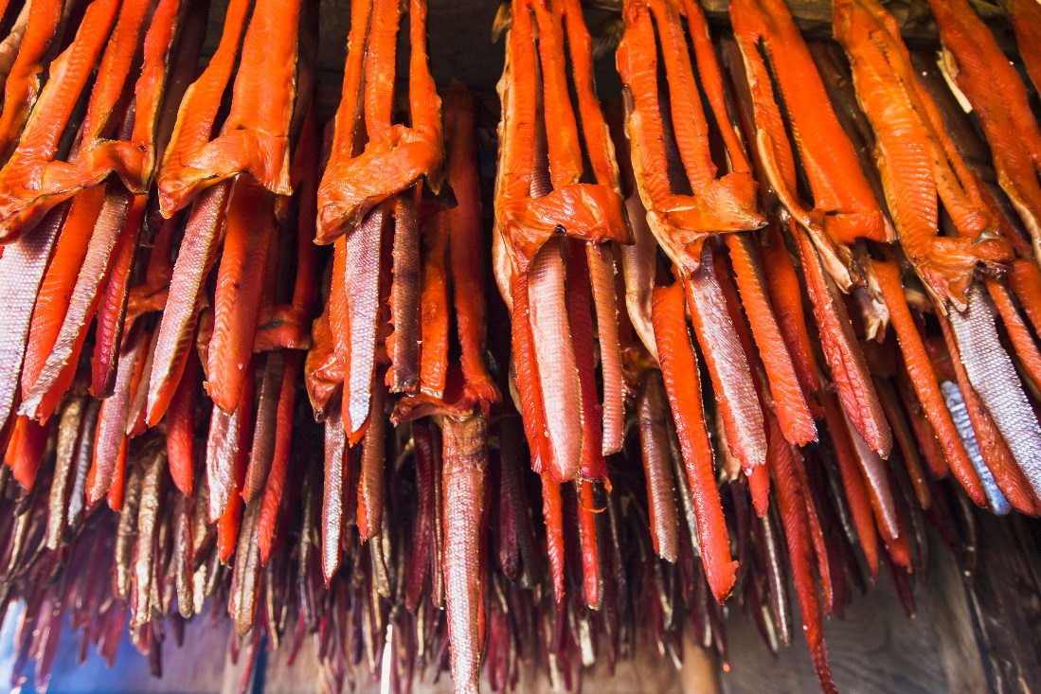
After cleaning, the women would put the fish on poles and prepare them for the smokehouse.

