Describing and Extending Repeating Patterns Behaviours/Strategies
Student randomly selects Attribute Blocks to extend the pattern.  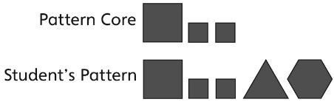 | 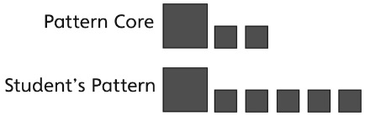  Student repeats only the last block in the pattern. | 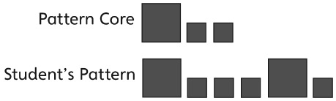  Student uses the correct blocks but places them in the wrong order.
Observations/Documentation
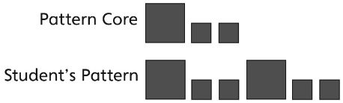  Student accurately extends the pattern by pointing to each element or by identifying the pattern core. | Student accurately extends the pattern but has difficulty describing the pattern. | Student accurately extends and describes the pattern.
Observations/Documentation

