Pan Card Recording Sheet (Addition)
Master 24a

Pan Card Recording Sheet (Addition)
Master 24b

Pan Card Recording Sheet (Subtraction)
Master 24c

Pan Card Recording Sheet (Subtraction)
Master 24d

Pan Card Recording Sheet (Expressions)
Master 24e

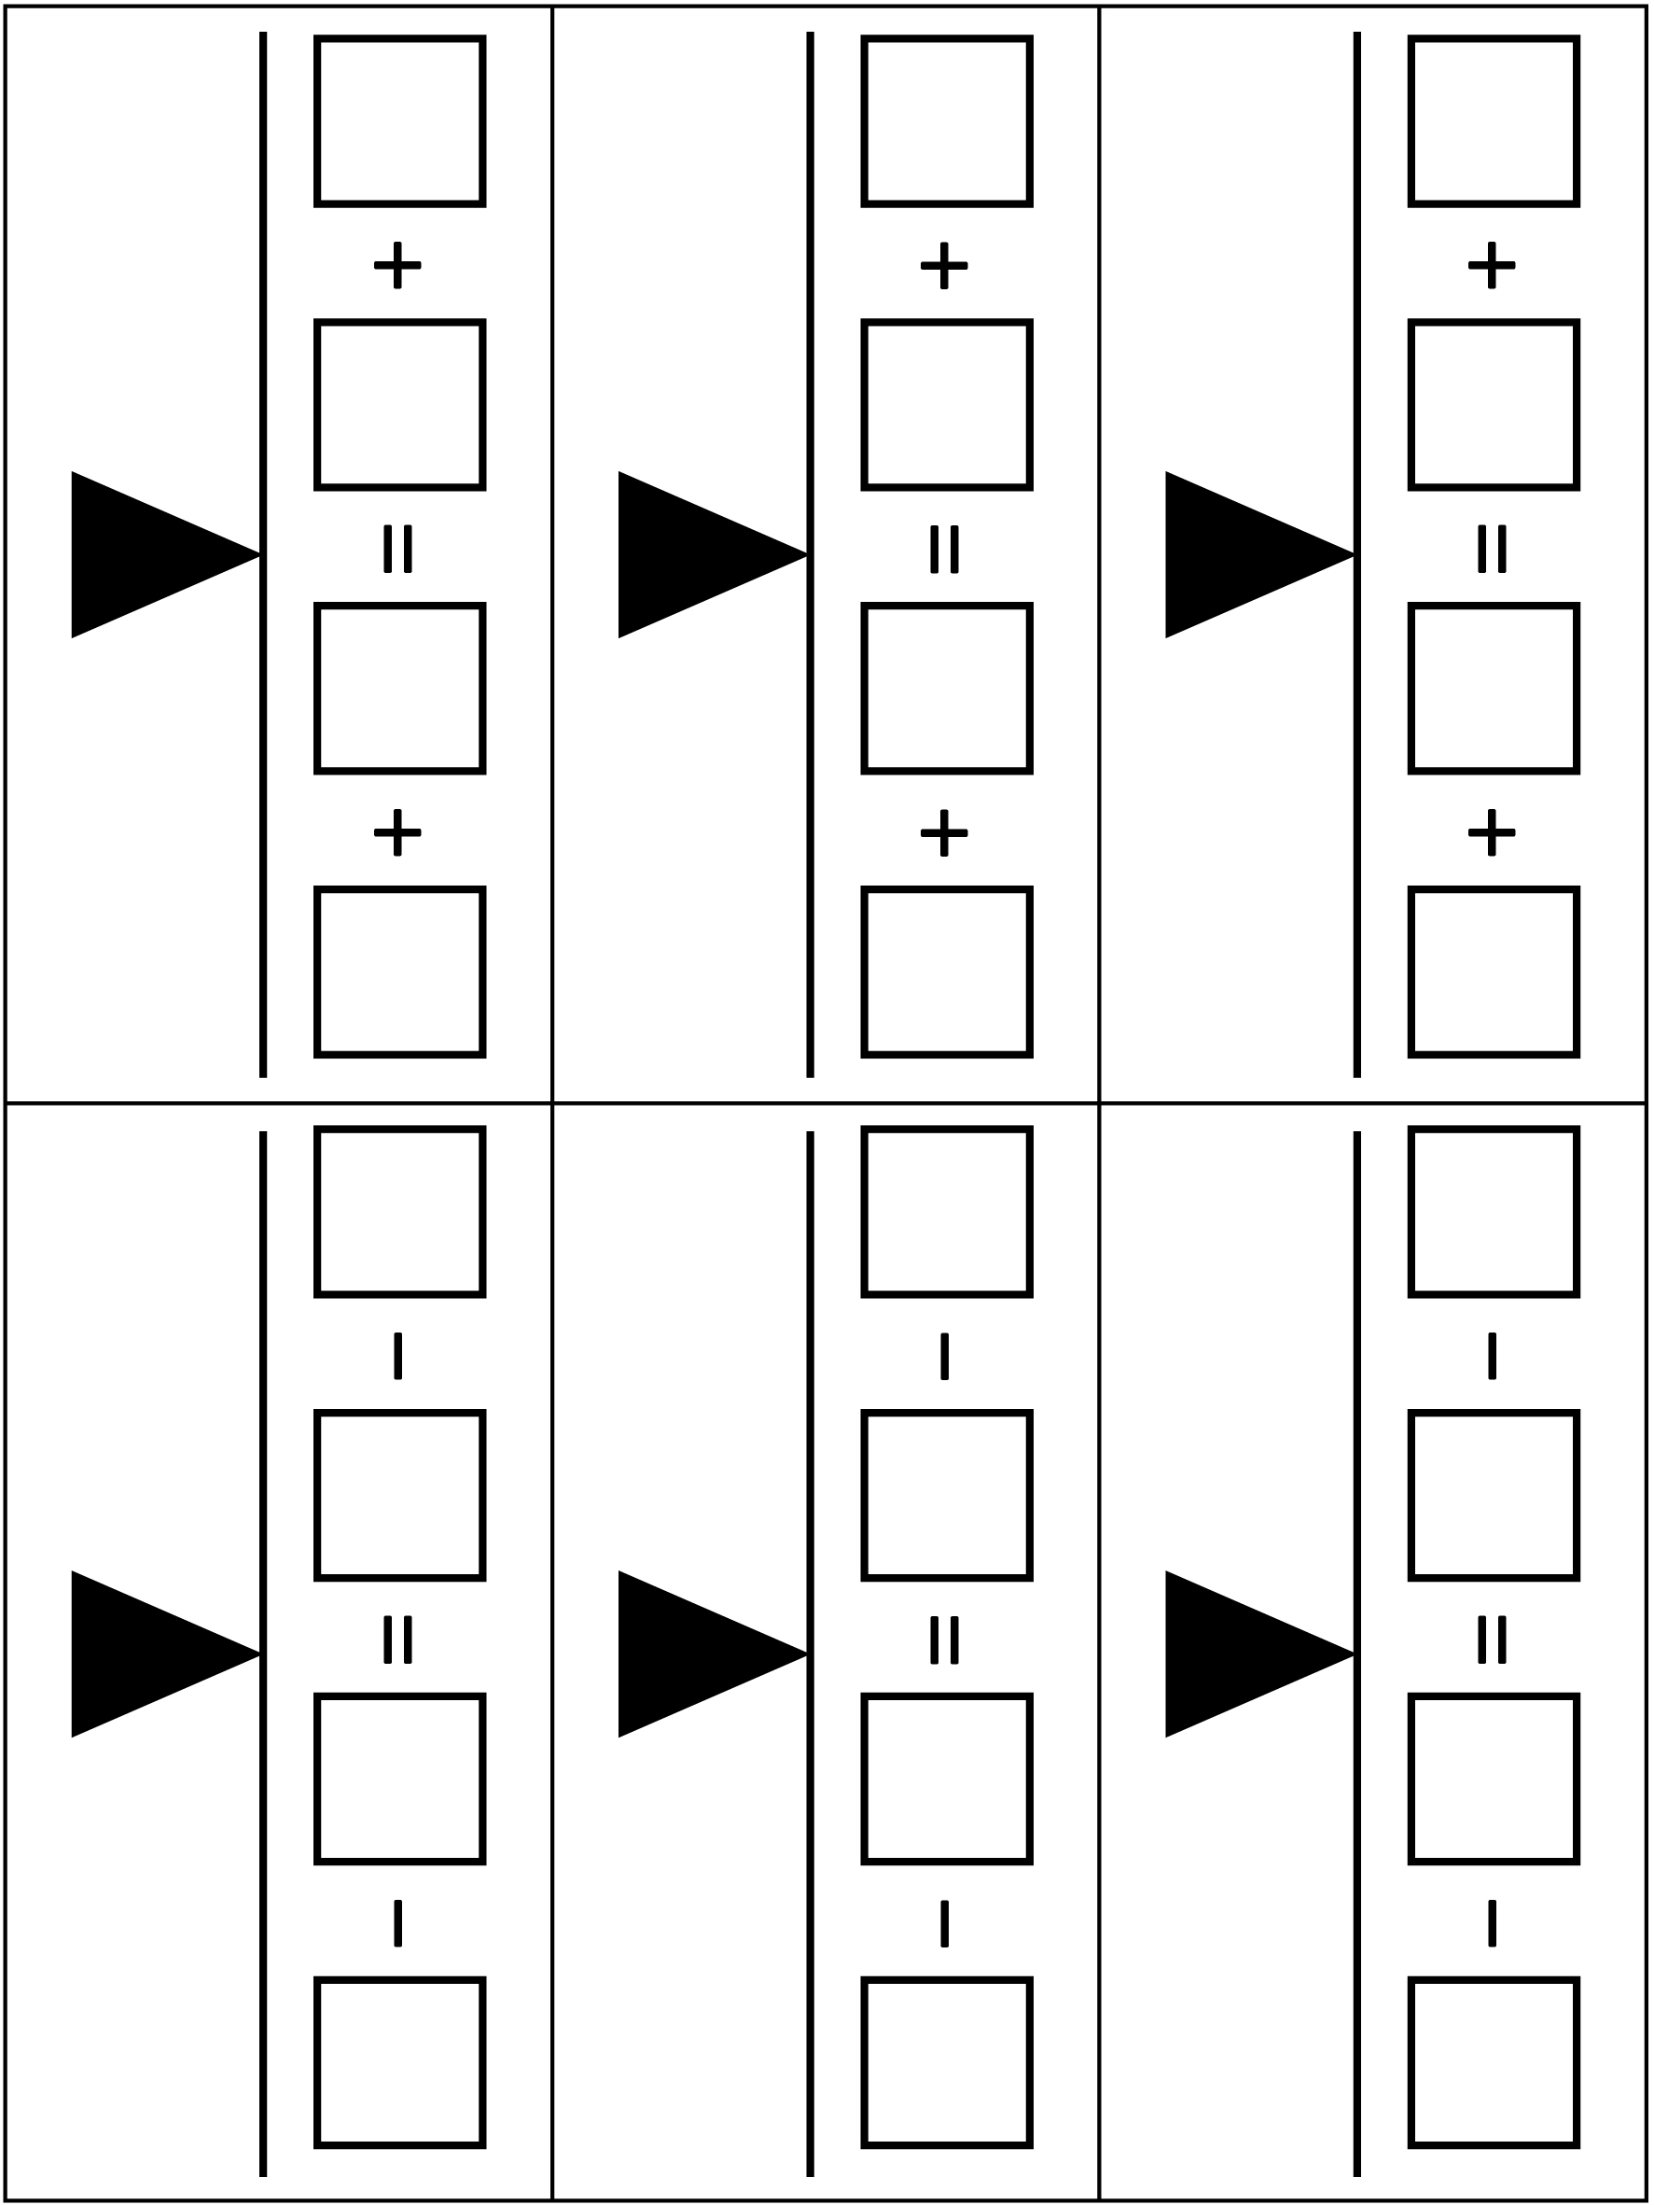

Pan Card Recording Sheet (Expressions)
Master 24f

