Identifying Triangles Behaviours/Strategies
Student does not have a mental image of a triangle and cannot identify a triangle. | 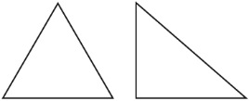  Student only recognizes an equilateral or right triangle as a triangle. | 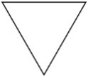  Student recognizes some triangles but thinks that a triangle that is oriented differently is not a triangle.
Observations/Documentation
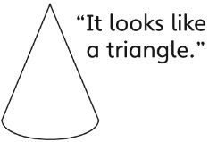  Student uses a shape’s appearance, not its geometric attributes, to identify a triangle. | Student successfully identifies triangles but has difficulty communicating why a shape was put in a particular column. | Student successfully identifies triangles and explains why a shape is or is not a triangle.
Observations/Documentation

