Analyzing and Identifying 2-D Shapes Behaviours/Strategies
- Student secretly picks a shape, but struggles to analyze the attributes of the shape and answers questions randomly. | - Student analyzes attributes of 2-D  shapes and answers questions  thoughtfully. Partner asks  repetitive questions.  “Does the shape have 3 sides?  Does the shape have 3 vertices?” | - Student asks questions, but ignores the answers and guesses (unable to identify the 2-D shape). | - Student asks questions, but they  focus on non-geometric attributes  (unable to identify the 2-D shape).  “Is the shape red?
Observations/Documentation
- Student asks questions to identify  2-D shapes, but uses non-mathematical language.  “Does it have points?  Does it look like a hockey card?” | - Student asks questions to identify  2-D shapes, but questions are  asked in a random order (does not appear to have a strategy).  “Does it have 3 sides?” Yes  “Does it have 4 vertices?” No  “Does it have straight sides?” No | - Student recognizes 2-D shapes, but cannot name some of them.  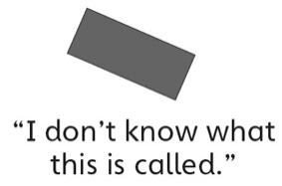 | - Student successfully identifies 2-D  shapes and names them.

