Identifying 3-D Solids in the Environment Behaviours/Strategies
- Student looks at a solid, but struggles to analyze its geometric attributes.  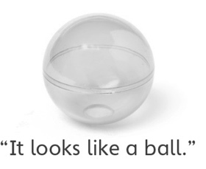 | - Student analyzes geometric attributes of  3-D solids, but cannot name the solids.  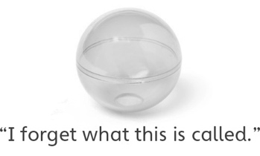 | 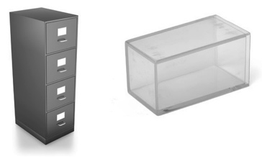  - Student identifies some 3-D solids in the  environment, but struggles when the orientation  of an object does not match his or her mental  image of the solid.
Observations/Documentation
- Student identifies some 3-D solids in the  environment, but struggles when the size of an object does not match the size of the given solid.  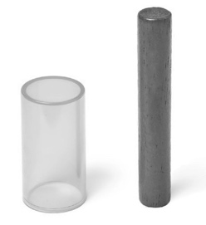 | - Student identifies 3-D solids in the environment, but struggles to explain why an object in the classroom is an example of the given 3-D solid. | - Student successfully analyzes geometric  attributes of 3-D solids, identifies 3-D solids in  the environment, and explains thinking.  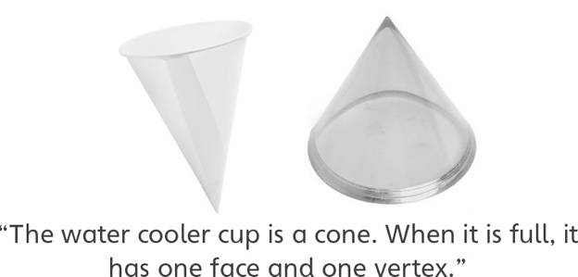
Observations/Documentation

