Applying Transformations to 2-D Shapes Behaviours/Strategies
1. Student identifies identical shapes with same orientation  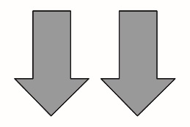  “These shapes have the same size and shape and are facing  the same way.” | 2. Identifies identical shapes with different orientations  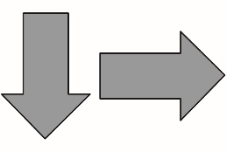  “These shapes are identical  because I can picture turning  one shape to match the other.” | 3. Student identifies translations but struggles to differentiate between reflections and rotations.  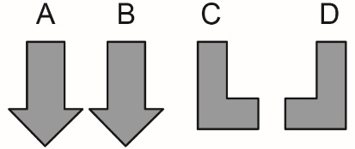  "I would translate A to the right  to get B. I am not sure if moving C  to D is a reflection or a rotation | 4. Student predicts and describes transformations of identical shapes and objects.  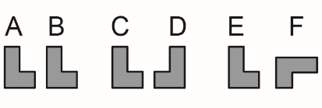  “When I translate a shape or object from A to B, the orientation stays  the same. When I reflect a shape  or object from C to D, I see a mirror image. When I rotate a shape  or object from E to F,  I get a different orientation.”
Observations/Documentation

