Exploring Shapes in
Powwow Dancers’ Regalia
Master 34a

- What shape is used within the design?
Does the shape slide?
Does the shape flip?
Does the shape turn?

a) Jingle Dress Dancer, page 10
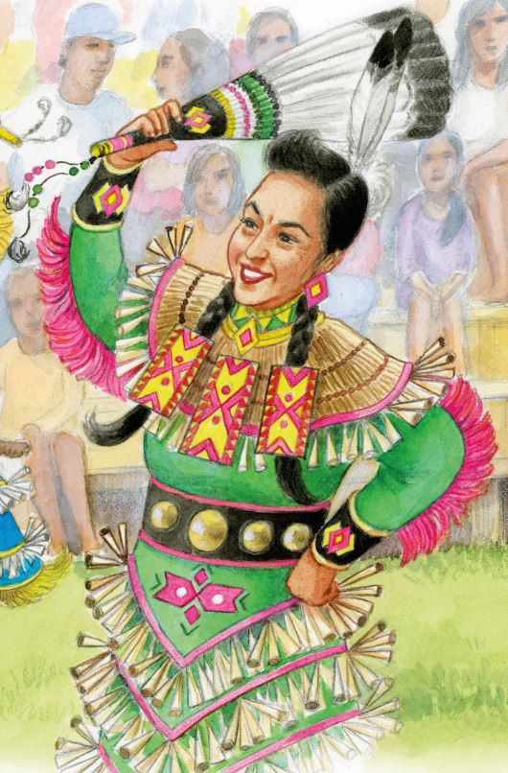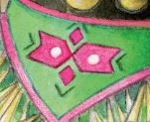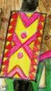

Exploring Shapes in
Powwow Dancers’ Regalia (cont’d)
Master 50b

Master 34b

b) Jingle Dress Dancer, page 11
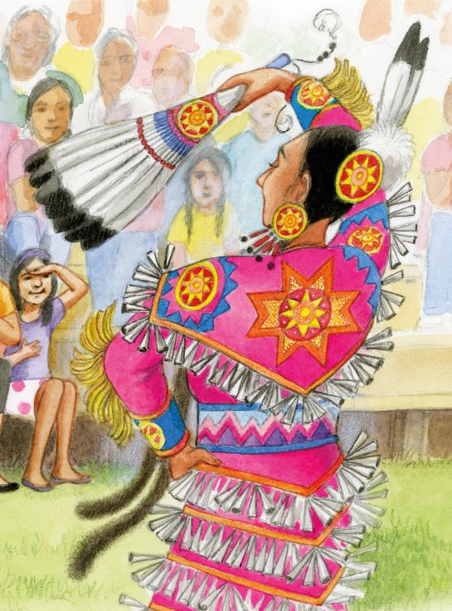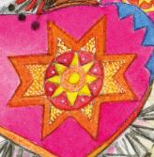
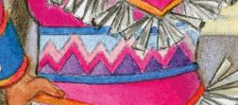

Exploring Shapes in
Powwow Dancers’ Regalia (cont’d)
Master 50b

Master 34c

c) Fancy Shawl Dancer, page 13
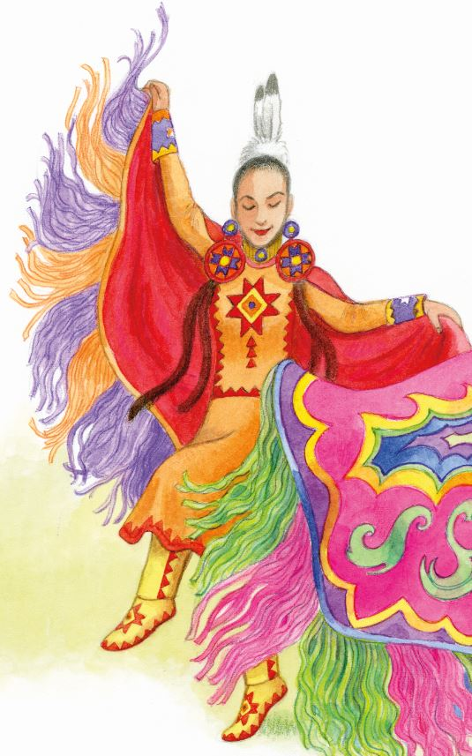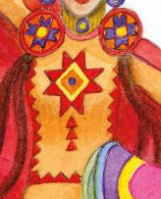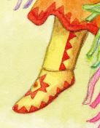

Exploring Shapes in
Powwow Dancers’ Regalia (cont’d)
Master 50b

Master 34d

d) Traditional Dancer, page 20
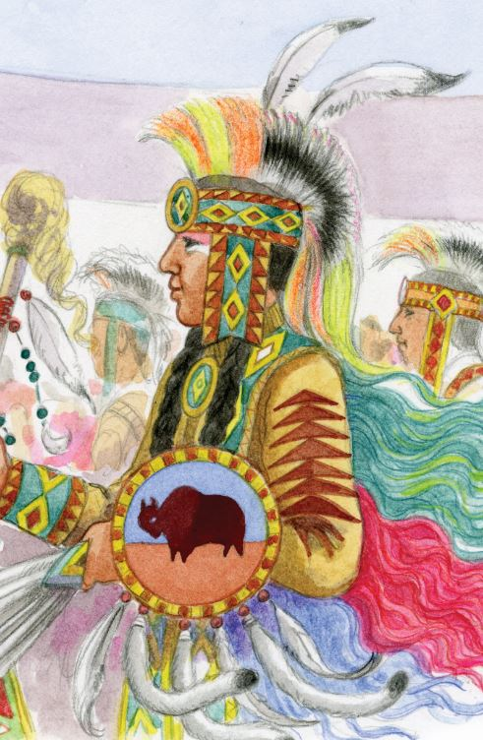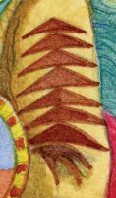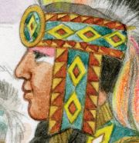

Exploring Shapes in
Powwow Dancers’ Regalia (cont’d)
Master 50b

Master 34e

e) Traditional Dancer, page 21
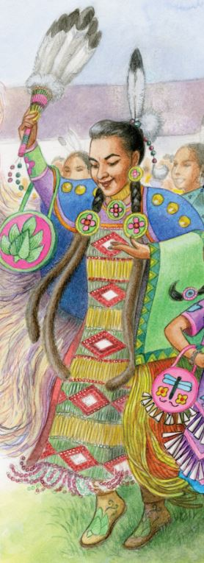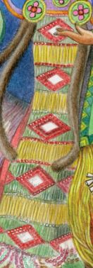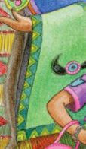

Exploring Shapes in
Powwow Dancers’ Regalia (cont’d)
Master 50b

Master 34f

2. Create a design using a shape with slides, flips, or turns to tell a story about yourself.

