**Master 37a**

**Hidden Shapes 2**

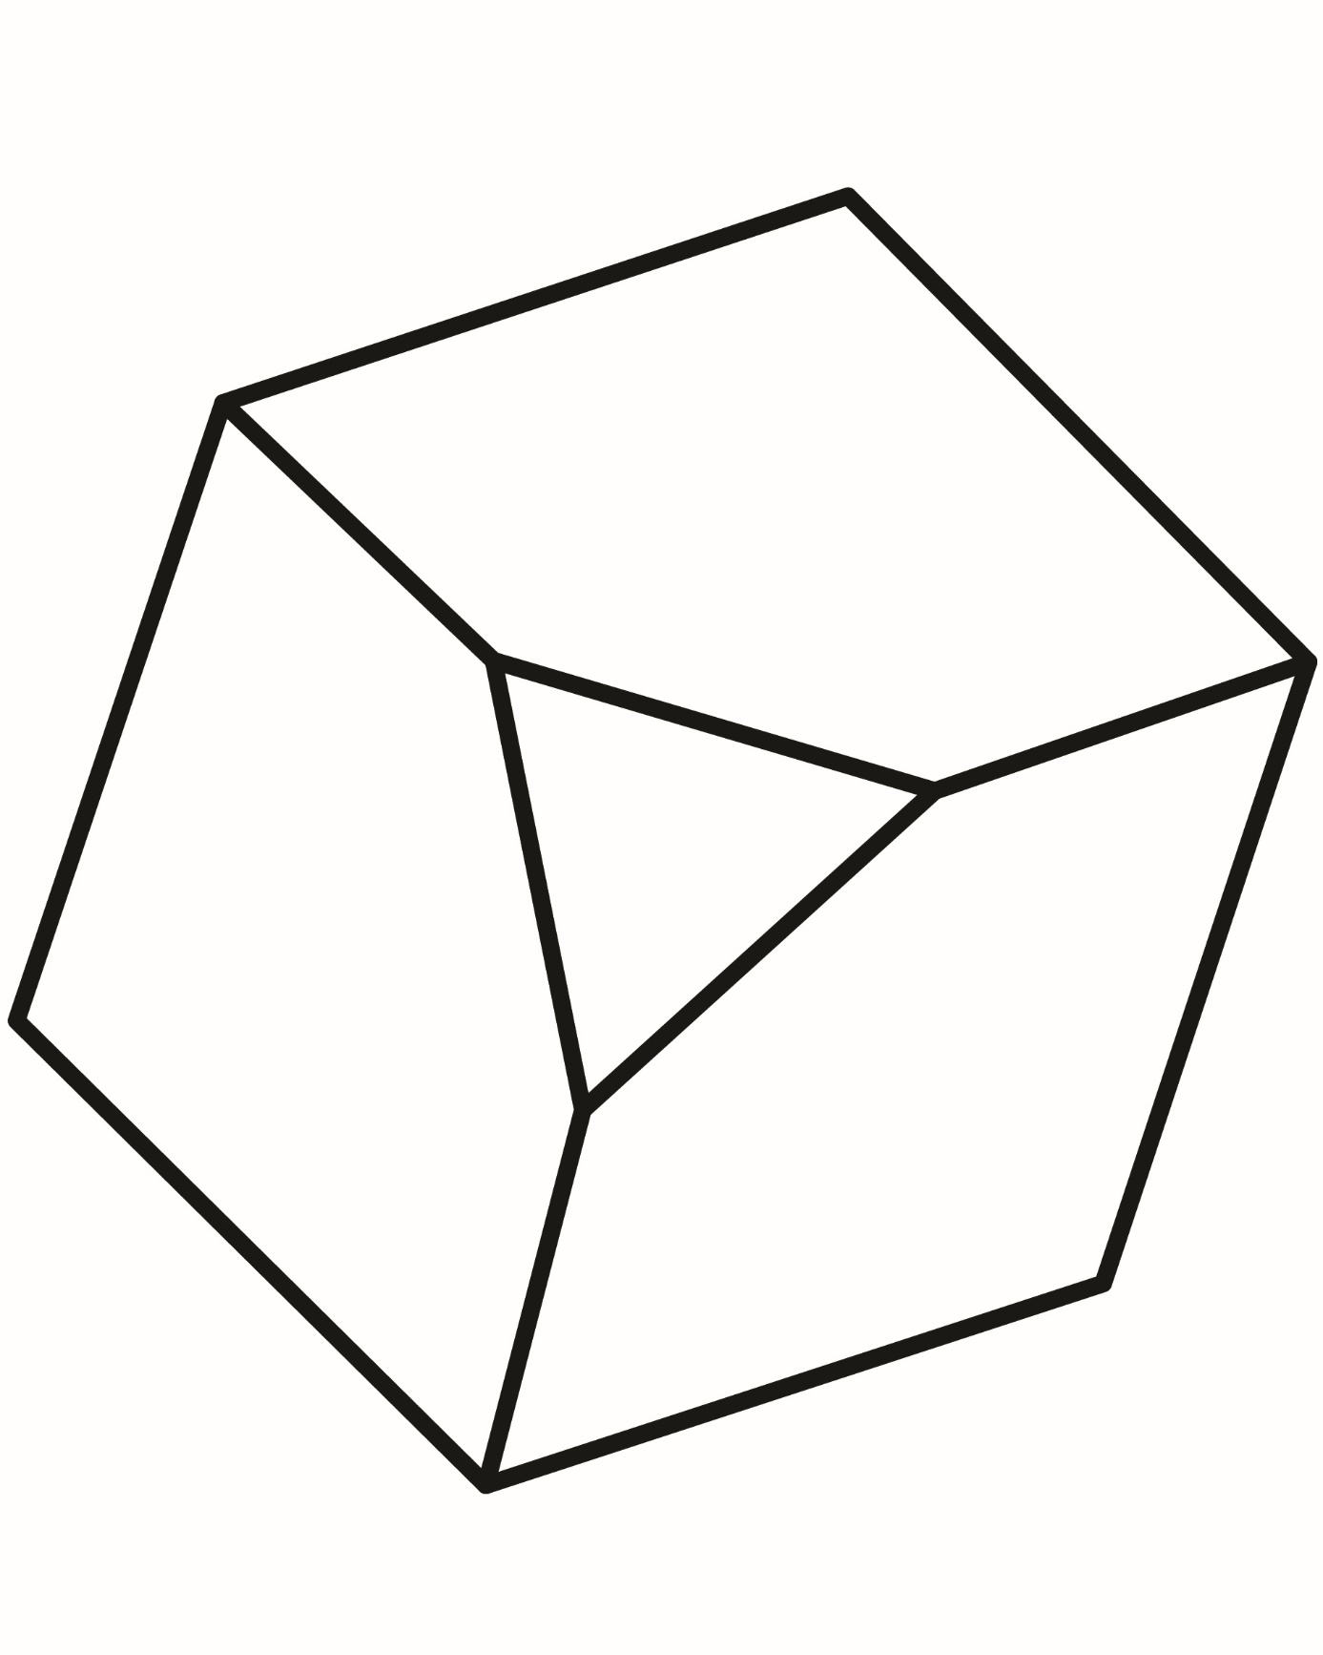

**Master 37b**

**Hidden Shapes 2**

