Sorting Shapes Using One Attribute Behaviours/Strategies
- Student chooses a familiar 2-D shape, but is  unable to name it. | - Student names familiar 2-D shapes, but  struggles to analyze their non-geometric and  geometric attributes.  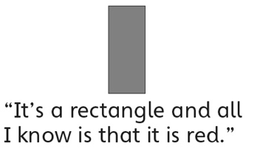 | - Student names familiar 2-D shapes and analyzes their attributes, but struggles to compare shapes to find similarities and differences.  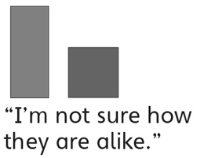
Observations/Documentation
- Student sorts a set of 2-D shapes in different  ways using a single attribute, but always uses a non-geometric attribute.  “I like to sort by colour or size.” | - Student successfully sorts a set of 2-D shapes in different ways using a single attribute, but struggles to describe the sort.  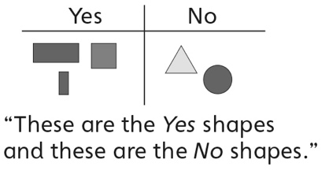 | - Student successfully sorts a set of 2-D shapes  in different ways using a single attribute and  describes the sort using math language.  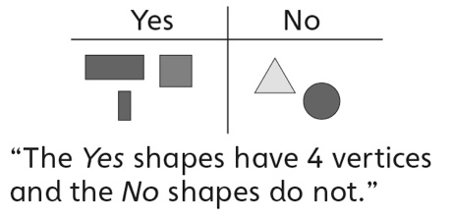
Observations/Documentation

