Sorting 3-D Solids Using One Attribute Behaviours/Strategies
- Student turns over an attribute card, but  struggles to sort a set of solids using a single  attribute and places solids randomly. | - Student sorts a set of solids using some  attributes, but when the attribute involves faces, student struggles to identify the faces of solids.  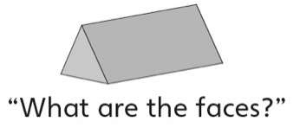 | - Student sorts a set of solids using some  attributes, but when the attribute involves  faces, student does not realize that more than  one shape can be a face of a solid.  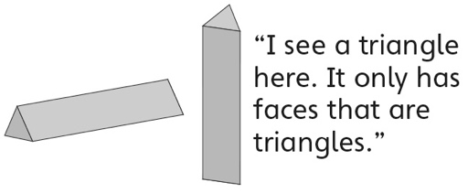
Observations/Documentation
- Student sorts a set of solids using some  attributes, but when the attribute involves faces, student does not recognize a shape when it does not match his or her mental image of the shape.  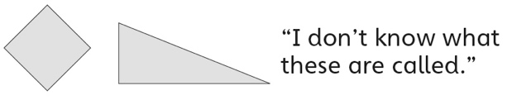 | - Student successfully sorts a set of solids in  different ways using a single attribute, but  struggles to explain why a solid was put in the  column it was. | - Student successfully sorts a set of solids in  different ways using a single attribute and  justifies the sort.
Observations/Documentation

