**Fill Me!**

**Intervention: Master 57a**

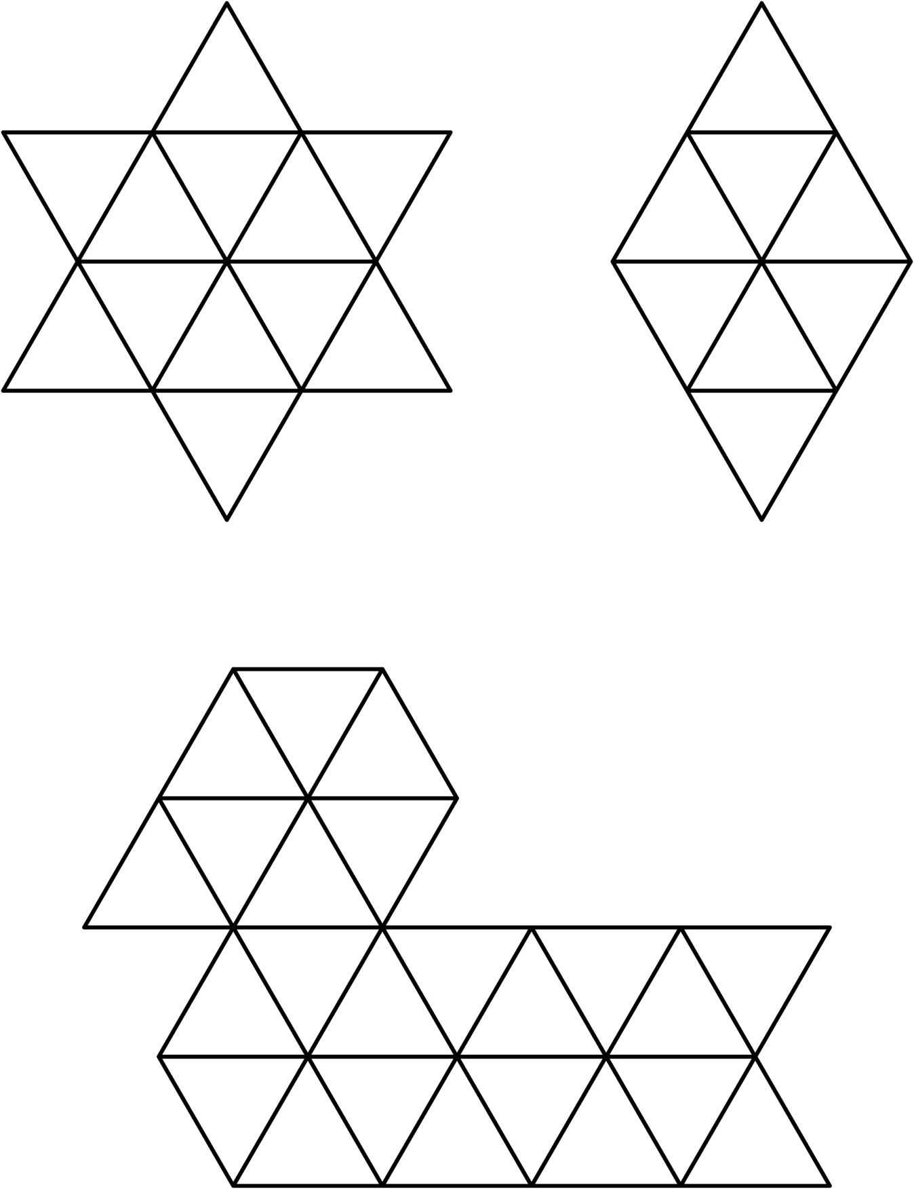

**Fill Me!**

**Intervention: Master 57b**

**(for Accommodations)**

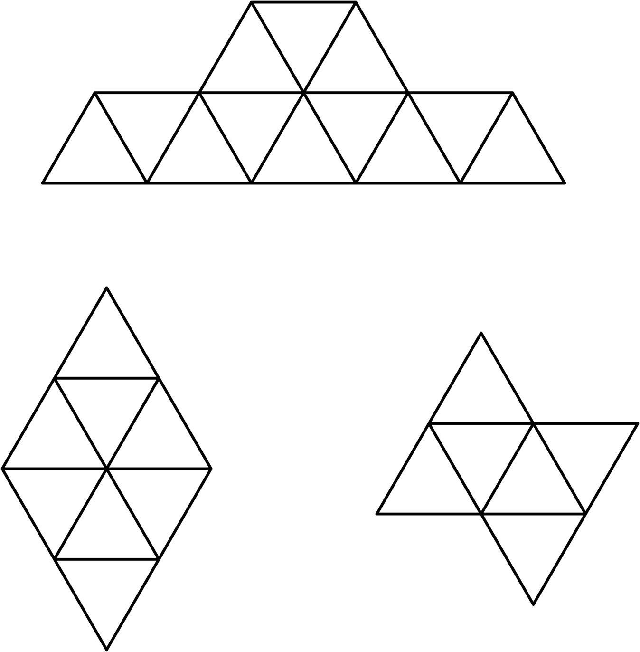

**Fill Me!**

**Intervention: Master 57c**

**(for Extension)**

