Comparing Quantities Behaviours/Strategies
- Student perceptually compares  quantities, comparing based on  "how things look."  “Mine has more because it looks  bigger.” | 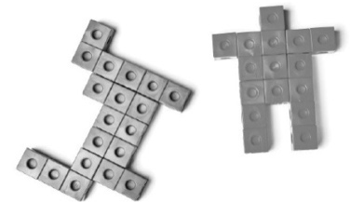  - Student compares quantities using one-to-one matching or counting (takes objects apart). | 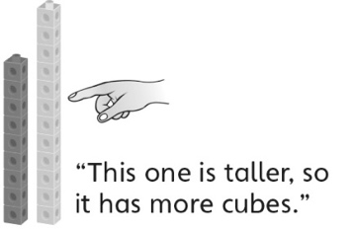  - Student compares quantities using grouping (groups cubes together to make towers). | - Student efficiently compares  quantities using benchmarks of  5 and 10.
Observations/Documentation
Finding How Many More or Less Behaviours/Strategies
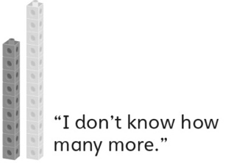  - Student builds objects, but struggles to determine how many more one quantity is compared to the other. | - Student determines how many  more/less by grouping (groups  cubes to make trains and then  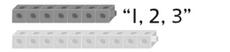  aligns the trains). | - Student determines how many  more/less using counting (finds  distance between numbers on a  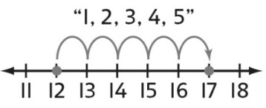  number line or hundred chart). | - Student successfully compares  quantities and determines how  many more/less one quantity is  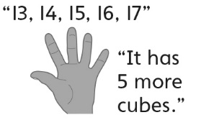  compared to another (e.g., counts on or back, tracking with fingers).
Observations/Documentation

