**Matching Cards**

**Intervention: Master 11a**

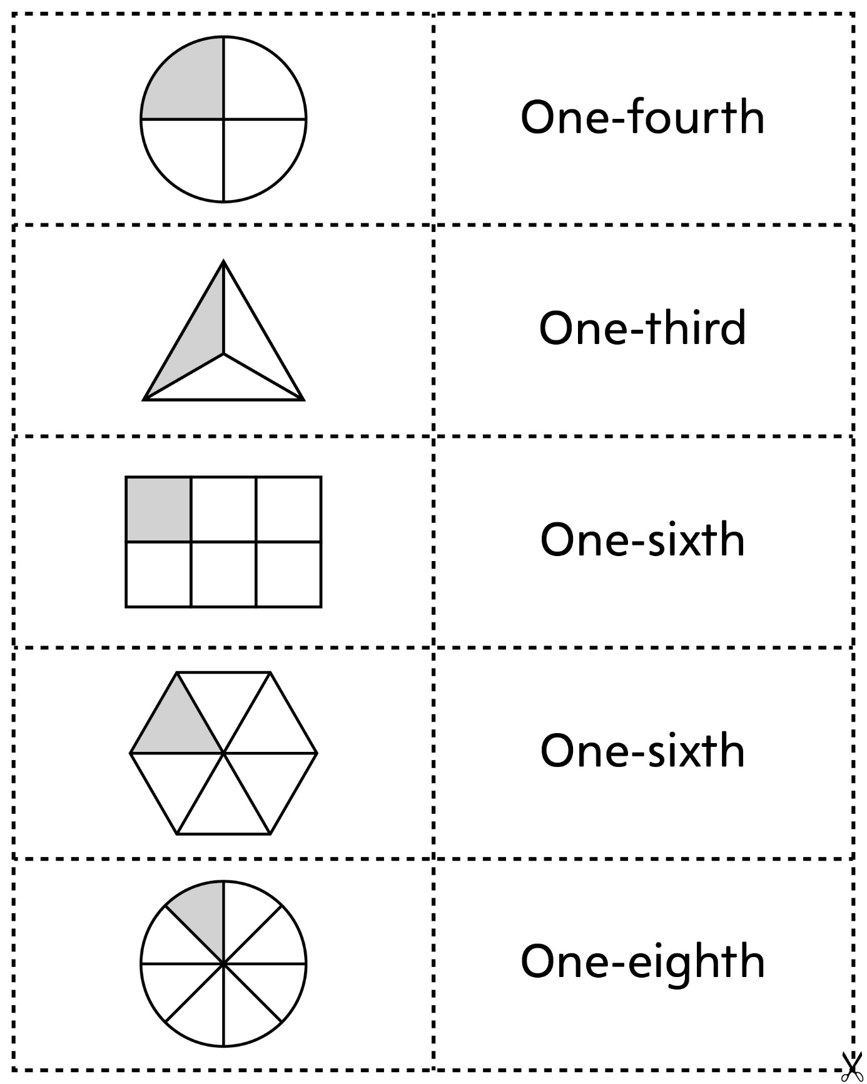

**Matching Cards**

**Intervention: Master 11b**

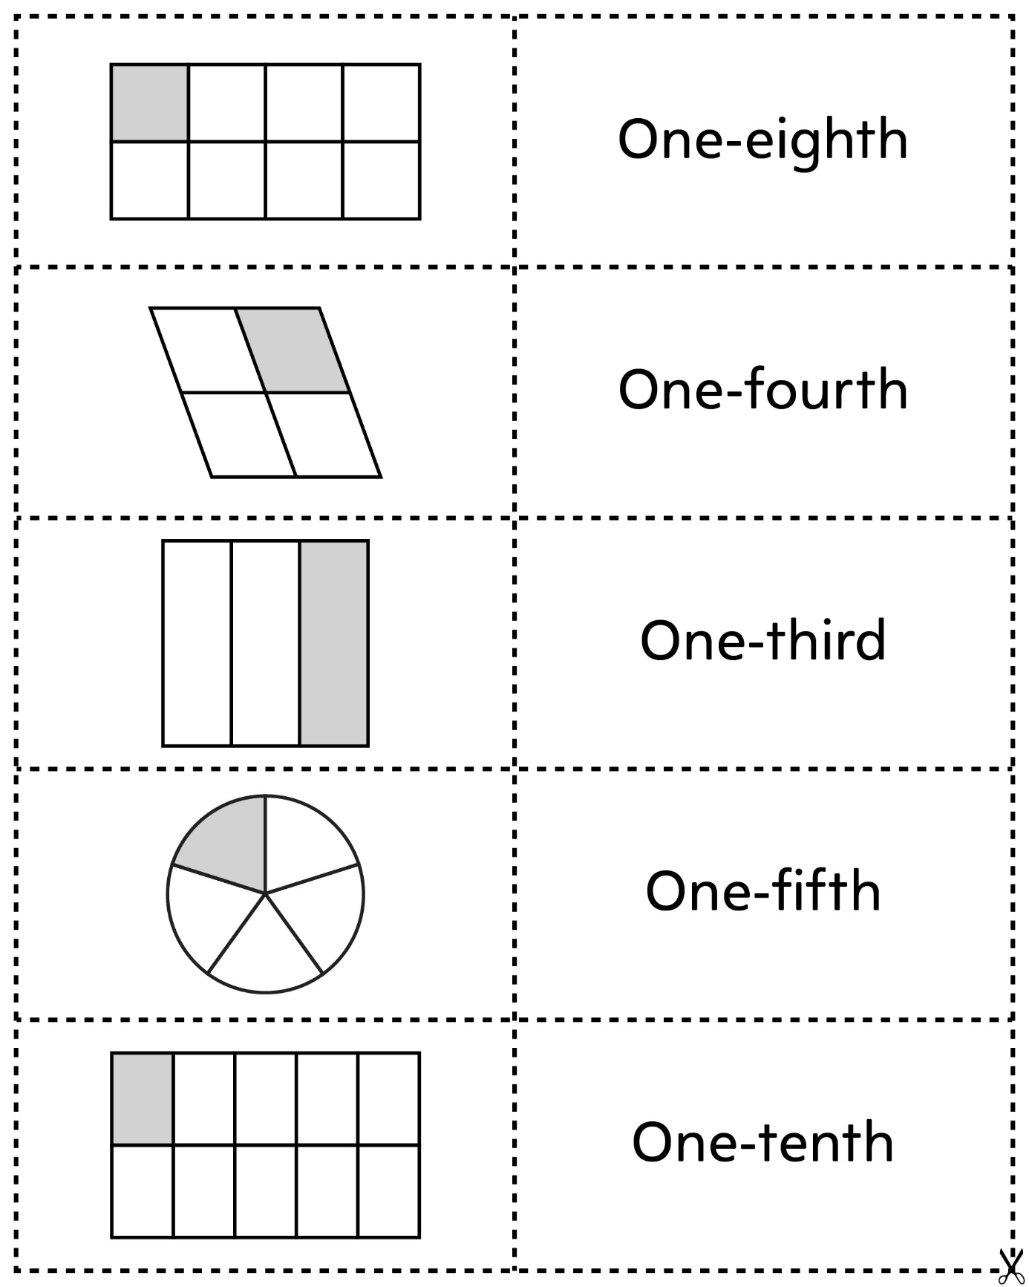

**Matching Cards**

**Intervention: Master 11c**

