Conceptualizing Addition and Subtraction Behaviours/Strategies
- Student plays with toy animals, but has difficulty using them to create an addition or subtraction problem. Story is not a math problem.  “Bears live in trees in the day.  Bears sleep in caves at night.” | - Student attempts to create an  addition or subtraction problem,  but does not ask a question.  “There are 8 bears in the trees.  3 bears come from the cave  to join them.” | - Student creates an addition or  subtraction problem and acts it  out, but cannot use symbols and  equations to represent it. | - Student creates an addition or  subtraction problem, acts it out,  and uses symbols and equations to represent it.  “There are 4 bears in the cave.  2 bears climb down the trees to  join them. How many bears are  now in the cave?”  “4 + 2 = 6”
Observations/Documentation
Addition and Subtraction Computational Behaviours/Strategies
- Student counts three times to add or subtract quantities.  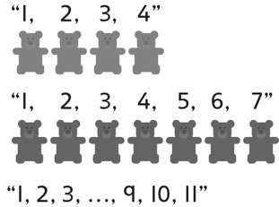 | - Student counts on or back to add  or subtract, but begins the count  with the number of objects in a  part or the whole.  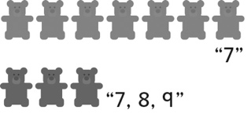 | - Student counts on or back with  concrete materials to add or  subtract quantities.  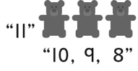 | - Student counts on or counts  back fluently to add or subtract  quantities.  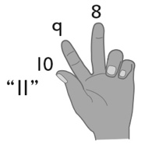
Observations/Documentation

