Creating Equal Sets Behaviours/Strategies
- Student places cubes in one pan,  but struggles to create an equal  set and randomly puts cubes in the other pan. | - Student creates a set that is equal to a given set, but thinks the sets must be identical (e.g., uses same number of each colour of cube).  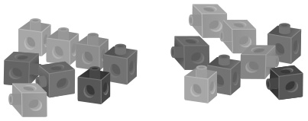 | - Student creates a set that is equal to a given set (e.g., counting or matching), but does not associate equal with balanced pans. | - Student successfully creates a set that is equal to a given set.  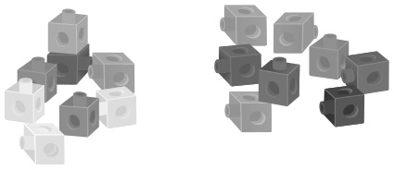
Observations/Documentation
Creating Not Equal Sets Behaviours/Strategies
- Student places cubes in one pan,  but struggles to create a not equal set and randomly puts cubes in the other pan. | - Student creates a set that is not  equal to a given set, but does not  know whether the new set has  more or fewer cubes. | - Student creates a set that is not  equal to a given set and knows  which set has more, but does not  associate more with the heights of the pans. | - Student successfully creates a set that is not equal to a given set.  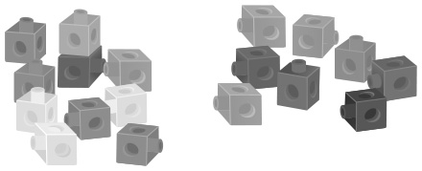
Observations/Documentation

