**Fill Me In!**

**Math Every Day: Master 14a**

**Pattern Block Outlines**

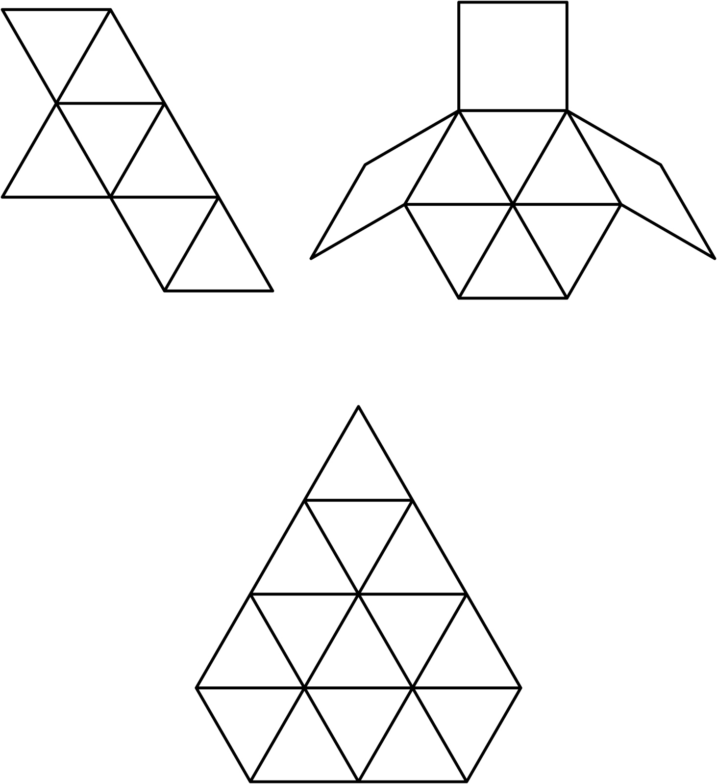

**Fill Me In!**

**Math Every Day: Master 14b**

**Pattern Block Outlines**

