**Draw the Shape Cards**

**Math Every Day: Master 15a**

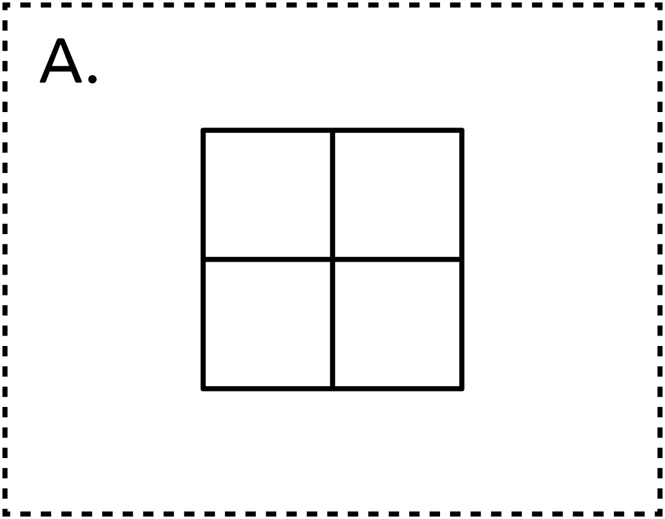

**Draw the Shape Cards**

**Math Every Day: Master 15b**

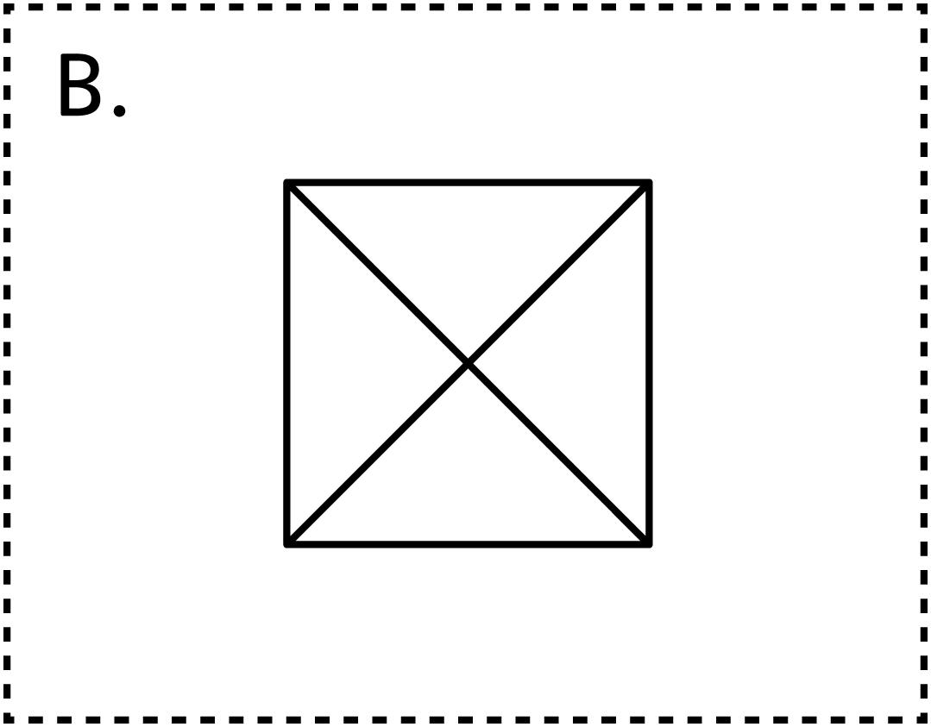

**Draw the Shape Cards**

**Math Every Day: Master 15c**

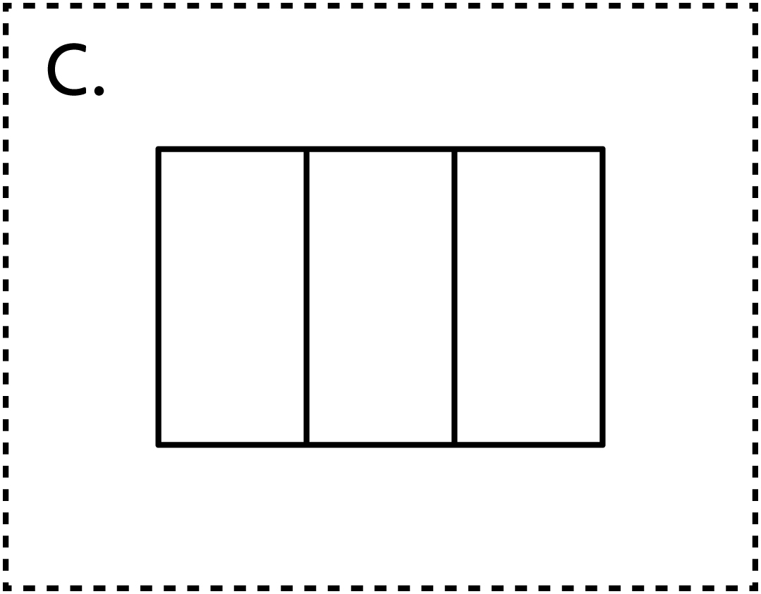

**Draw the Shape Cards**

**Math Every Day: Master 15d**

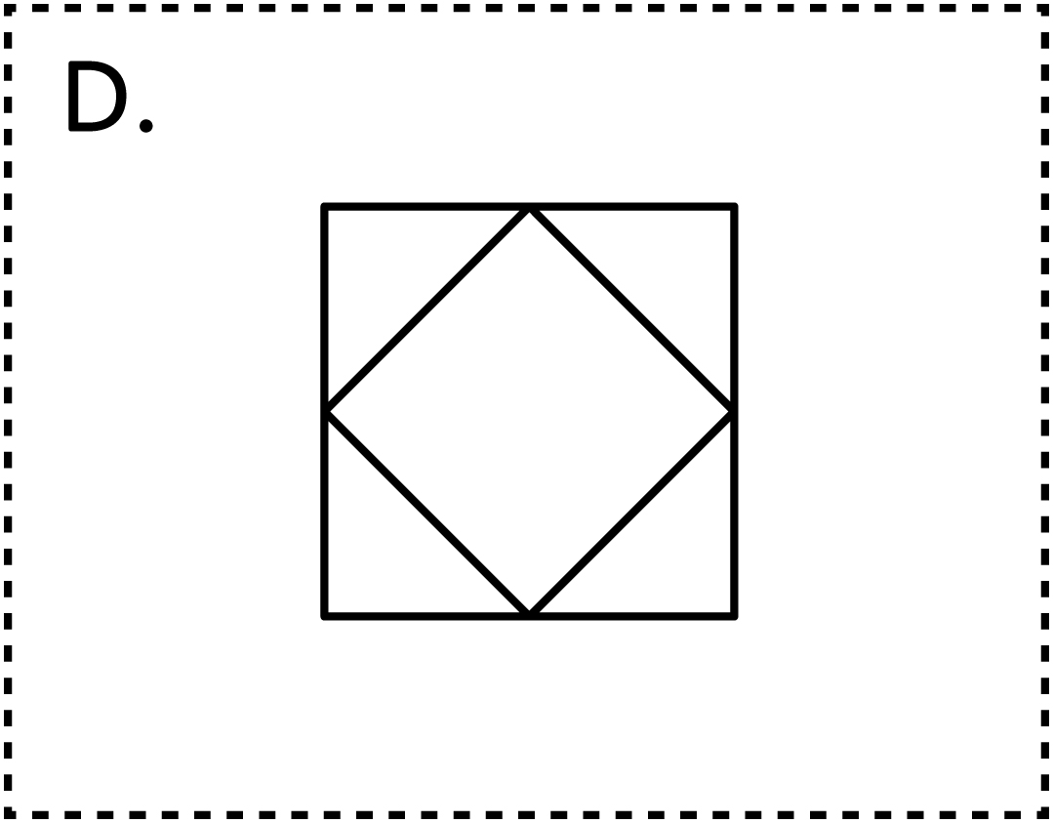

**Draw the Shape Cards**

**Math Every Day: Master 15e**

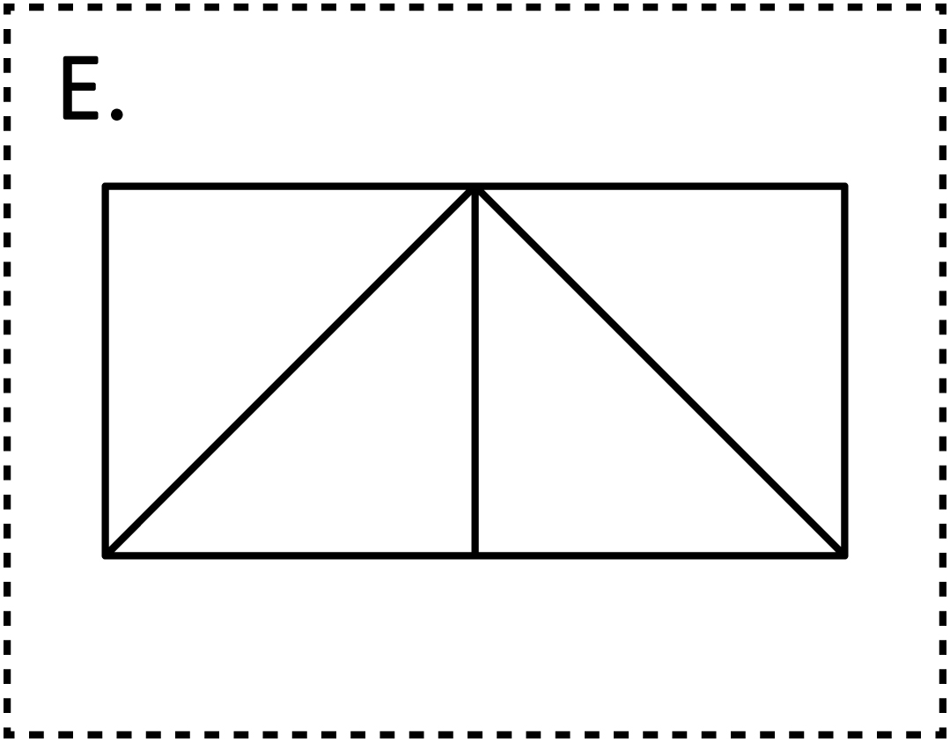

**Draw the Shape Cards**

**Math Every Day: Master 15f**

