**Month Cards**

**Math Every Day: Master 11a**

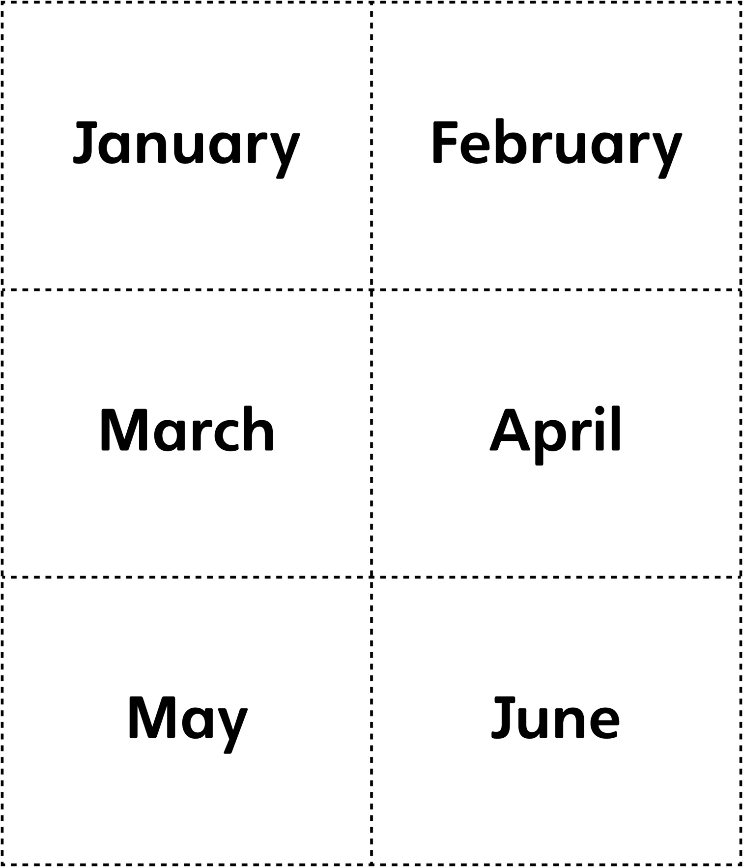

**Month Cards**

**Math Every Day: Master 11b**

