Measuring Behaviours/Strategies
- Student estimates length using non-standard units or a benchmark for 1 centimetre, but  estimates are unreasonable. | - Student does not select an appropriate non-standard unit  to measure.  “I will use the pan balance to  measure length.” | - Student measures length, but focuses on using one  measuring tool.  “I like to measure length  with paper clips”
Observations/Documentation
- Student measures objects by  length using non-standard units, or a benchmark for 1 centimetre, but leaves gaps or overlaps.  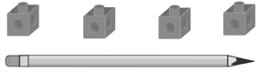 | - Student successfully measures  objects by length using non-standard units or a benchmark for 1 centimetre, but does not include a unit with the measure.  “Its length is 6.” | - Student successfully measures  objects by length using non-standard units or a benchmark for 1 centimetre.
Observations/Documentation

