Skip-Counting by 10s Spider Webs
Master 5a

Start at 0. Skip-count by 10s.

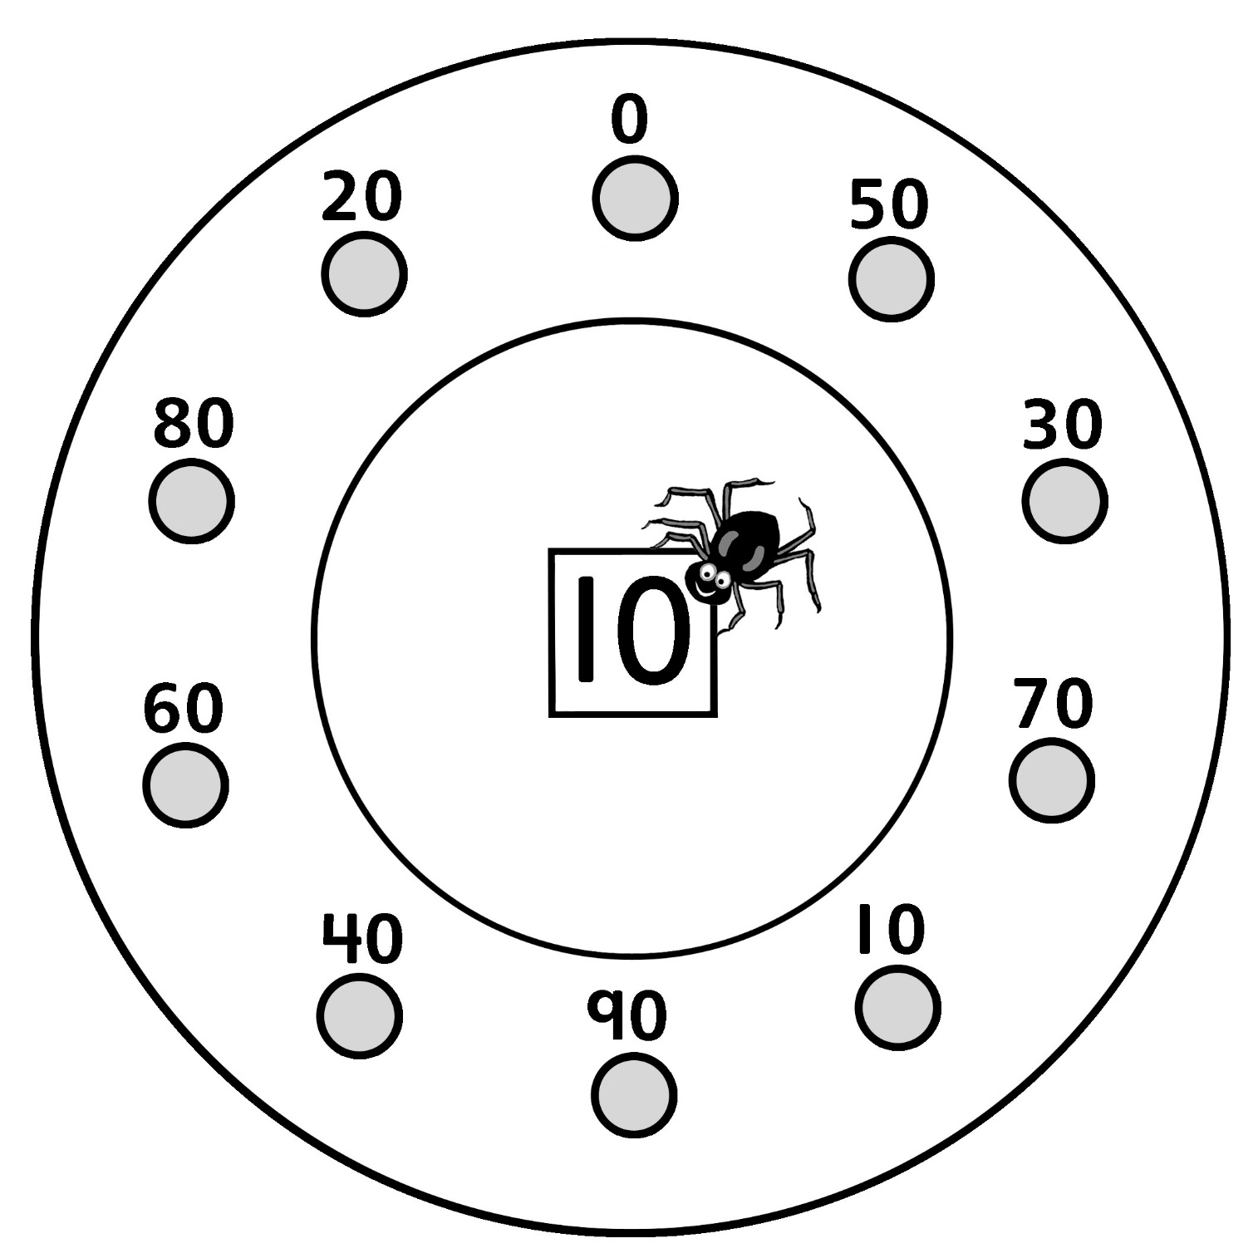

Skip-Counting by 10s Spider Webs
Master 5b

Start at 10. Skip-count by 10s.

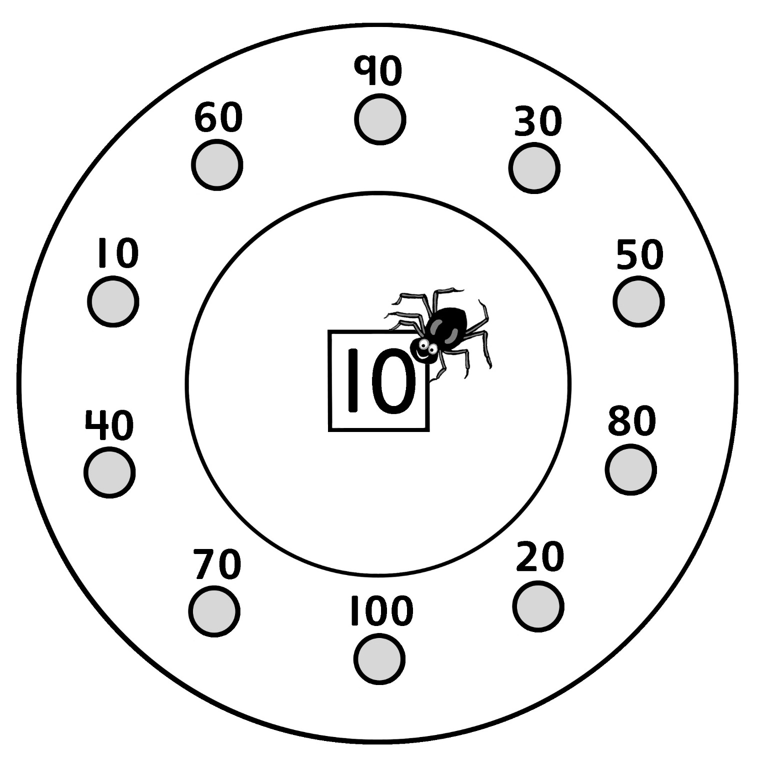

Skip-Counting by 10s Spider Webs
Master 5c

Start at 100. Skip-count by 10s.

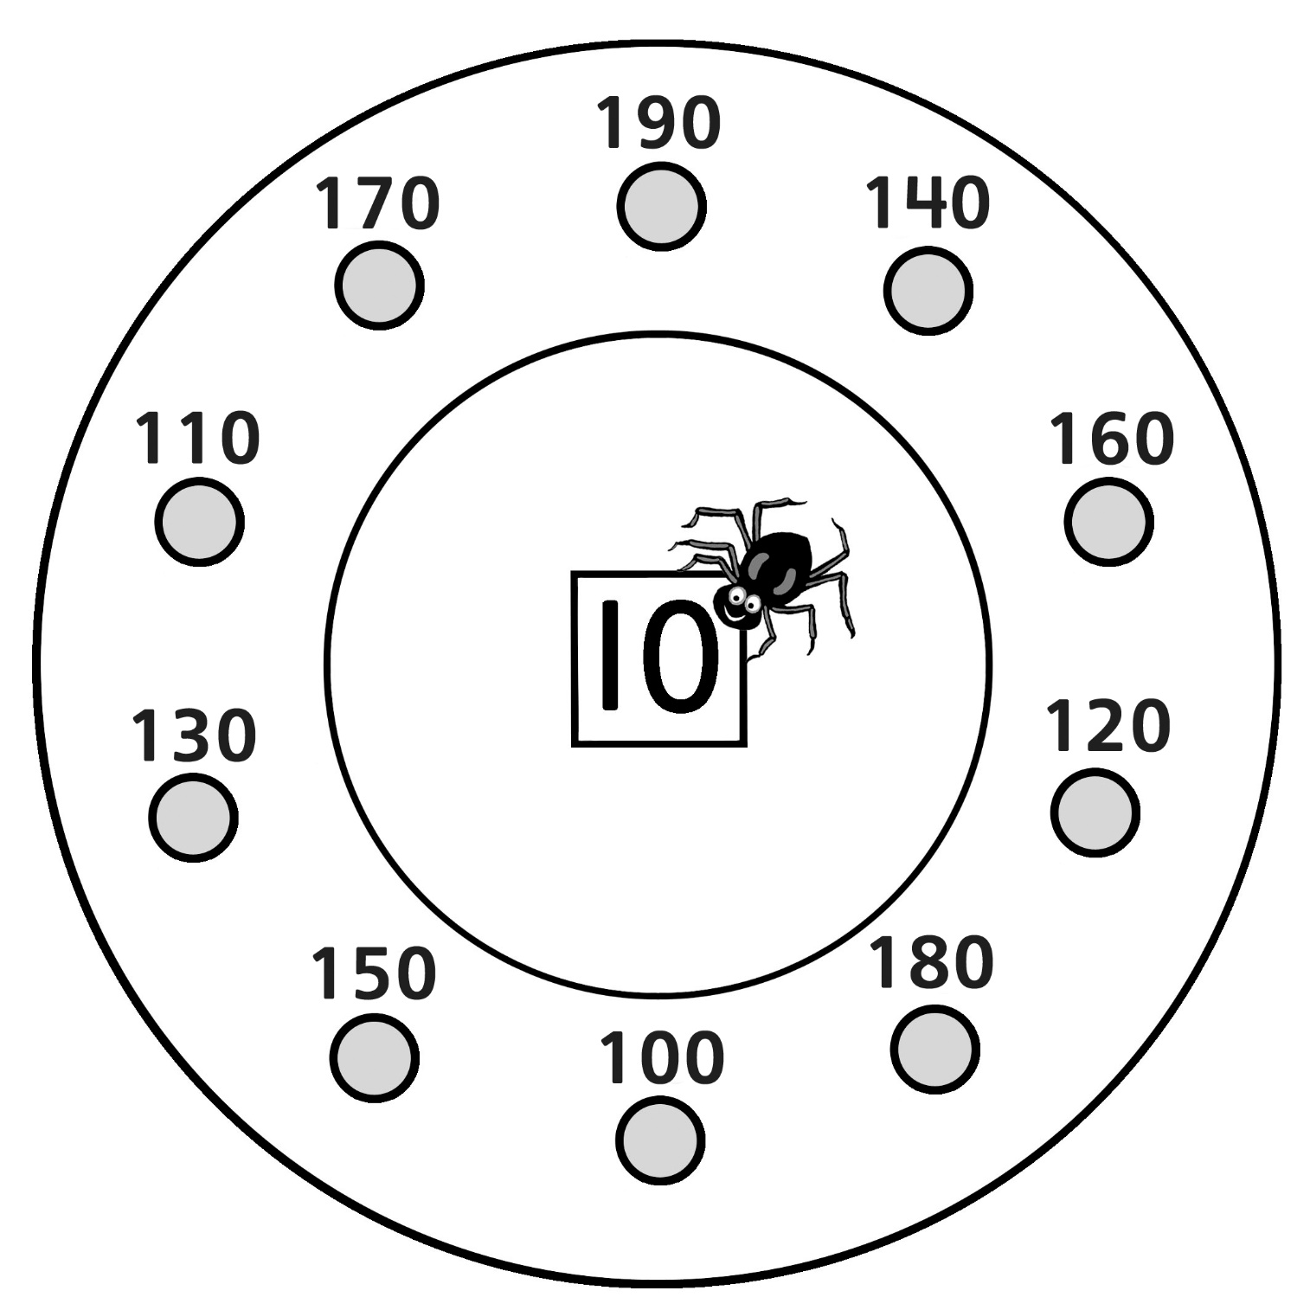

Skip-Counting by 10s Spider Webs
Master 5d

Start at 510. Skip-count by 10s.

