Estimating Quantities Behaviours/Strategies
1. Student guesses or counts.  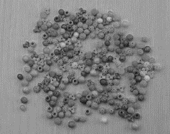  “About 500!” | 2. Student creates a benchmark for 10.  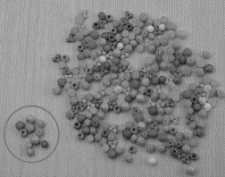  “There are lots of groups of 10.” | 3. Student creates a benchmark for 100.  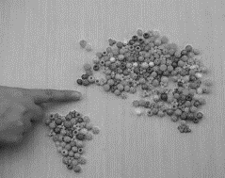  “I counted out 100.”
Observations/Documentation
4. Student compares to a referent (more or less).  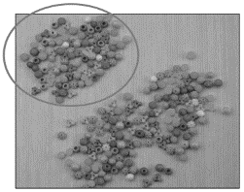  “More than 200.” | 5. Student gives estimate as a range by physically grouping objects.  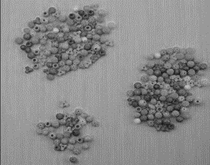  “Between 200 and 300.” | 6. Student estimates using visual strategies.  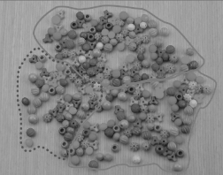  “About 250: 2 groups of 100  and half of another 100.”
Observations/Documentation

