Comparing and Ordering Numbers Behaviours/Strategies
1. Student orders numbers randomly.  125 245 179  “I just put down any card.” | 2. Student models with manipulatives.  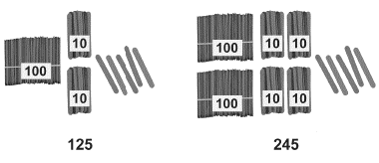 | 3. Student uses benchmark on hundred chart or number line.  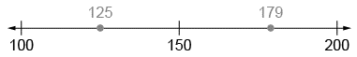  “I compared the numbers to 150.”
Observations/Documentation

4. Student visualizes hundred chart or  number line.  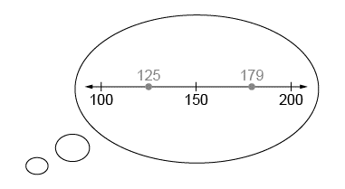  “I picture 179 farther to the right than 125.” | 5. Student compares numbers, digit by digit (with the same place value).  “Both start with 1, 2 is less than 7, and 5 is less than 9. So, 125 is less than 179.” | 6. Student orders three or more quantities (e.g., using early place-value, mental strategies).  179 245 326  “326 is greatest because 3 hundreds is more than both 2 hundreds and 1 hundred.”
Observations/Documentation

