Task Cards: Odd or Even Numbers
Master 25a

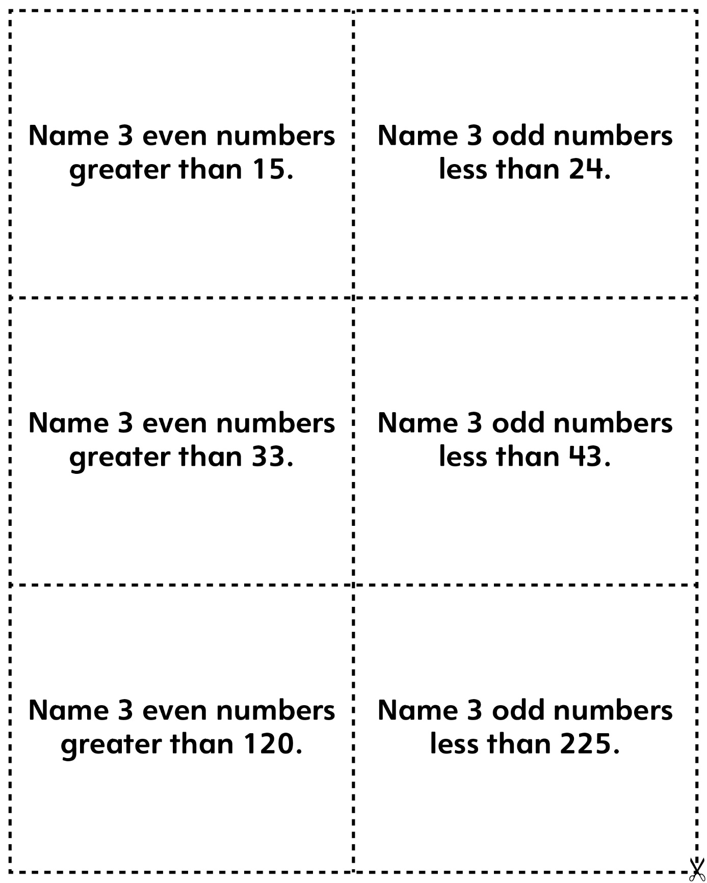
Task Cards: Odd or Even Numbers
Master 25b

(for Accommodations)

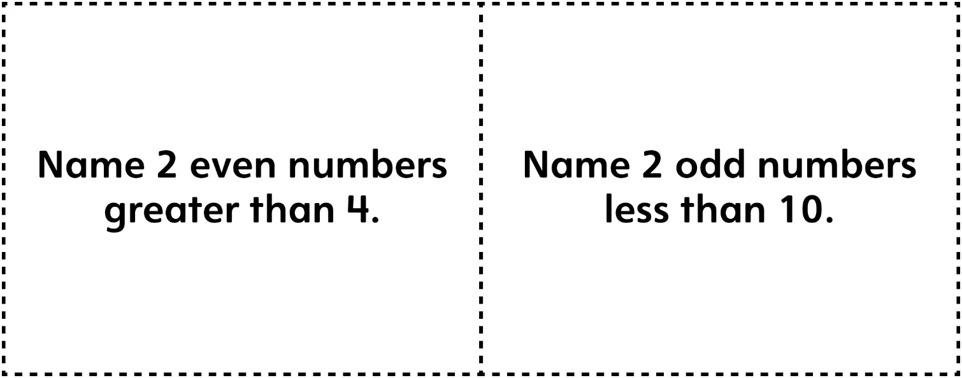

Task Cards: Odd or Even Numbers
Master 25c

(Blank Cards)

Task Cards: Comparing and Ordering
Master 25d

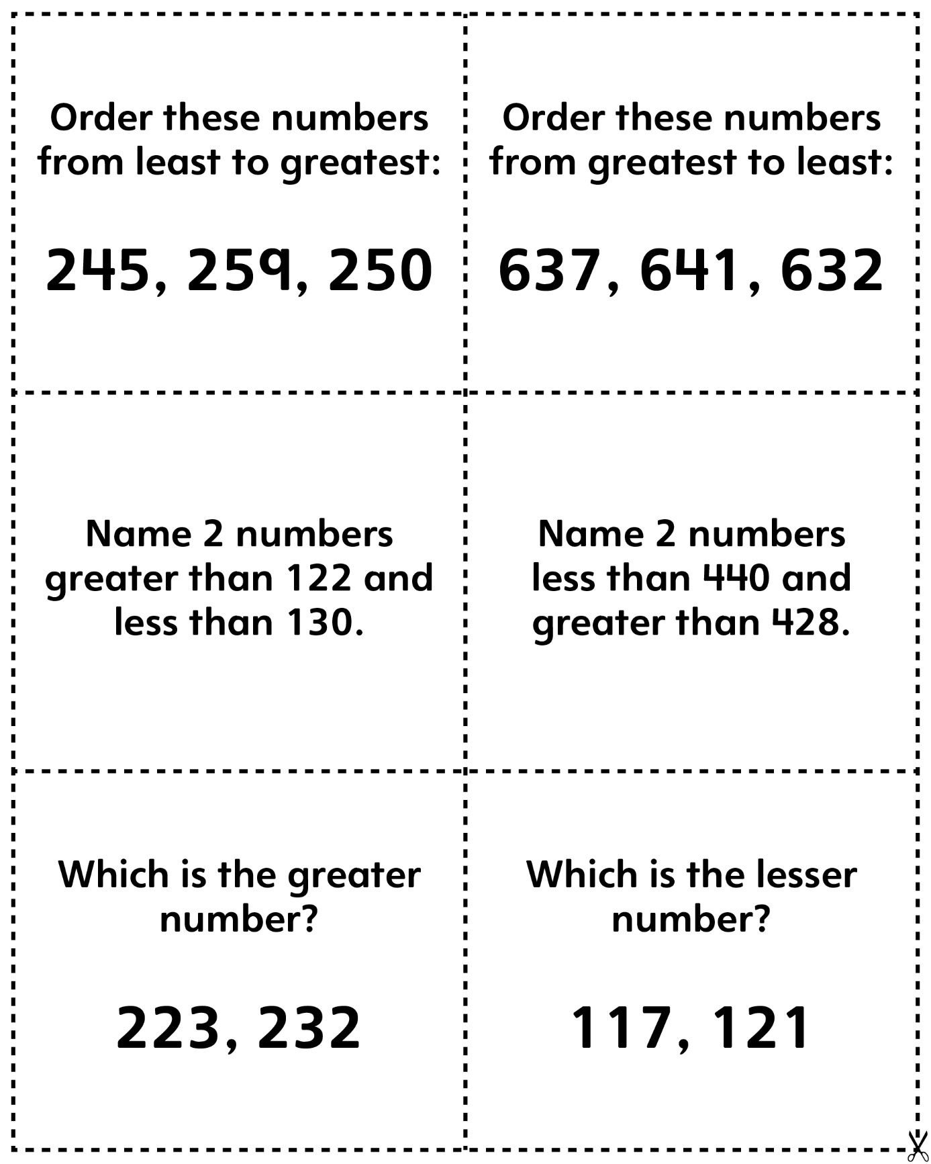
Task Cards: Comparing and Ordering
Master 25e

(for Accommodations)

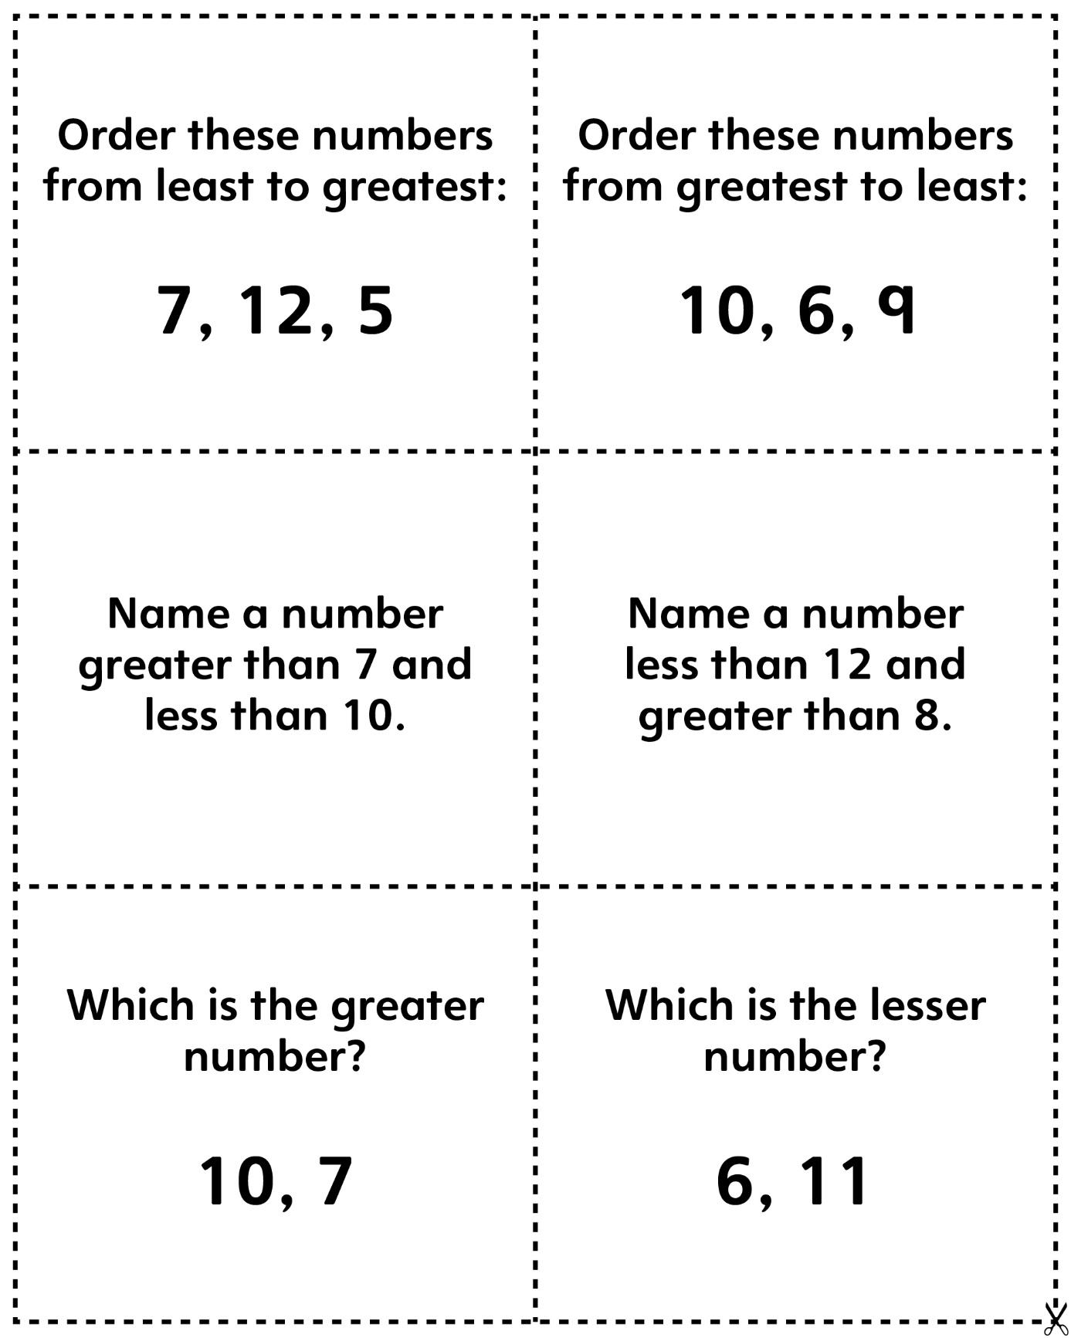
Task Cards: Comparing and Ordering
Master 25f

(Blank Cards)

