Base Ten Fish Cards
Master 28a

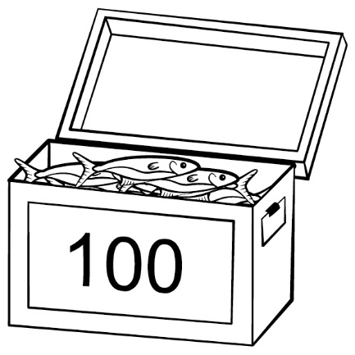
Base Ten Fish Cards
Master 28b
Master 5b

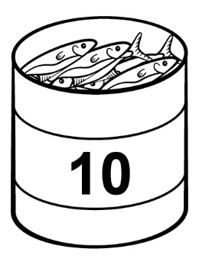

Base Ten Fish Cards
Master 28c

