Composing and Decomposing 3-Digit Numbers Behaviours/Strategies
- Student composes and decomposes using hundreds, tens, and ones (one way)  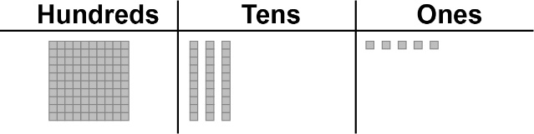  “I modelled 135.” | - Student composes and decomposes using hundreds, tens, and ones (more than one way).  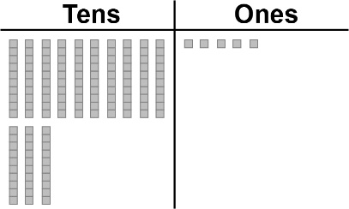  "I traded the hundred for 10 tens." | - Student uses place value to write a number in different ways  “One hundred thirty-five is  1 hundred, 3 tens, 5 ones;  13 tens, 5 ones or |||||||||||||•••••"
Observations/Documentation

Composing and Decomposing 3-Digit Numbers Behaviours/Strategies (cont’d)
- Student understands relationships  among digits  "The digit 4 in 475 represents 4 hundreds,  40 tens, or 400 ones." | - Student compares two 3-digit numbers where all digits are different.  Compare 475 and 739.  “The digit 4 in 475 represents 4 hundreds,  and the digit 7 in 739 represents 7 hundreds.  7 hundreds is greater than 4 hundreds.  So, 739 is greater than 475." | - Student uses place value to compare and order numbers.  Bison: 739 kg; Grizzly bear: 268 kg;  Brown bear: 278 kg  “The bison has the greatest number of hundreds. Both bears have 2 hundreds so I will compare  the tens. 6 tens is less than 7 tens.  So, 268 is less than 278.  From greatest to least: 739 kg, 278 kg, 268 kg.”
Observations/Documentation

