Comparing and Regrouping Fractional Parts Behaviours/Strategies
- Student turns over a card, but  struggles to partition wholes into  equal parts and does not know  how many parts are in the whole.  “How many parts do I need  to show sixths?” | - Student turns over a card, but  struggles to partition wholes  into equal parts and chooses an  inappropriate whole (e.g., uses  Pattern Blocks to show fourths). | - Student chooses a whole, but  struggles to partition it into equal  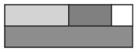  parts, and parts are not all equal or they do not cover the whole exactly. | - Student partitions wholes into  equal parts, but struggles to  compare with unit fractions.  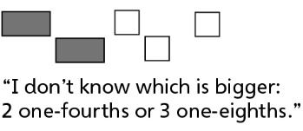
Observations/Documentation
- Student partitions wholes into  equal parts, but compares parts of different wholes. | - Student partitions wholes into  equal parts, but struggles to  combine equal parts to make  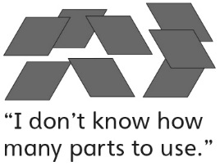  wholes. | - Student combines equal parts to  make one whole, but struggles to name the unit fraction used.  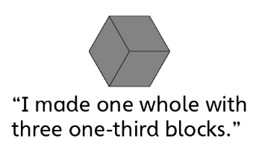 | - Student successfully partitions  wholes into equal parts, compares with unit fractions, and combines equal parts to make wholes.
Observations/Documentation

