Story Problems 2
Master 71a

(Whole Unknown)

Note: Story Problem Card 3 is for use as an accommodation.
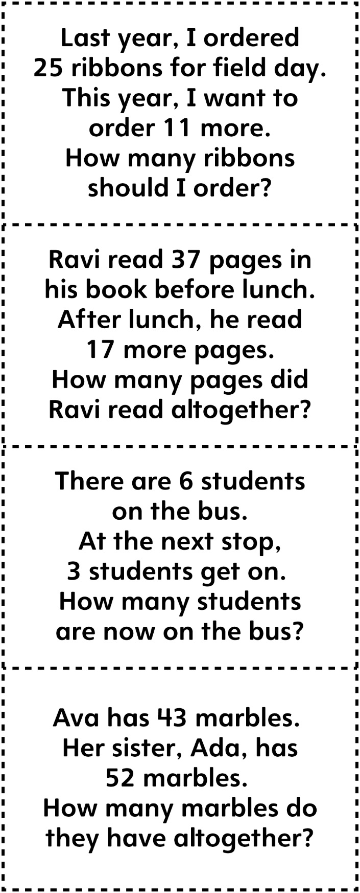

Story Problems 2
Master 71b

(Whole Unknown)

