**Question Cards**

**Master 84a**

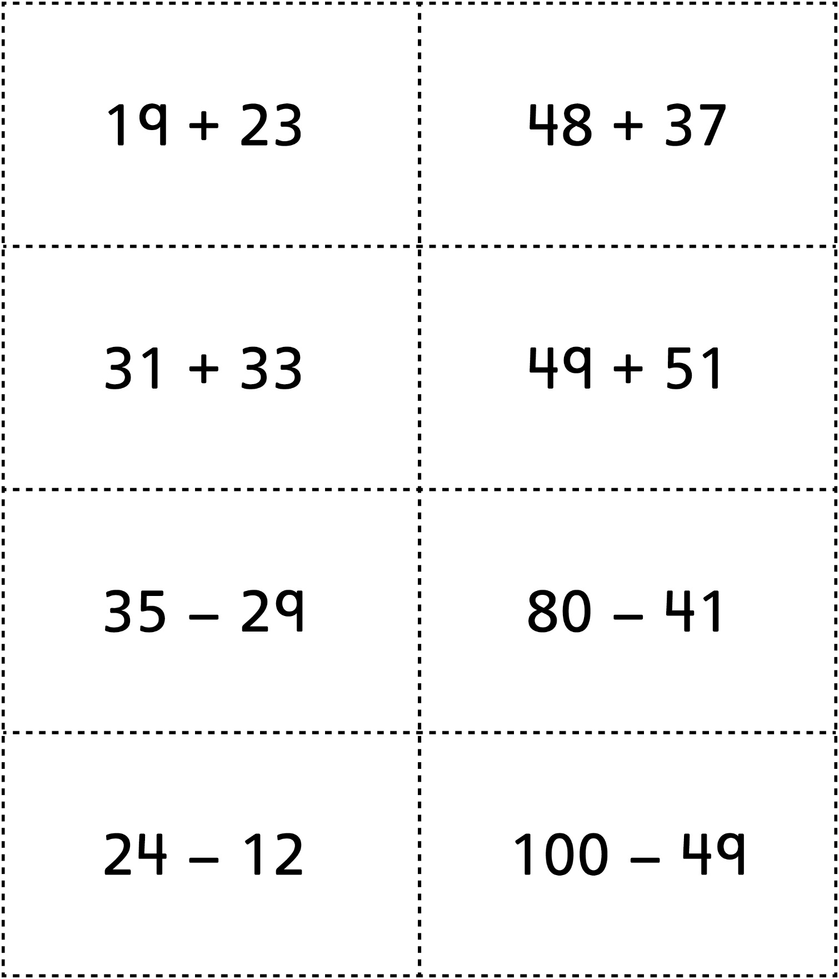

**Question Cards (for Accommodations)**

**Master 84b**

