Grouping Items in 2s, 5s, and 10s Behaviours/Strategies
- Student counts all items by 1s rather than  grouping items in 2s, 5s, and 10s.  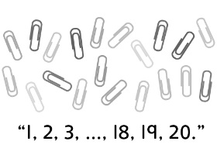 | - Student groups items in 2s, 5s, and 10s, but  groups are not all equal. | - Student groups items in 2s, 5s, and 10s, but does not recognize that the quantity will be the same when the items are grouped in different ways.  “When I grouped in 2s, there were 20. I’m not sure how many there would be if I grouped in 5s.”
Observations/Documentation
- Student groups items in 2s, 5s, and 10s, but  ignores the leftover(s).  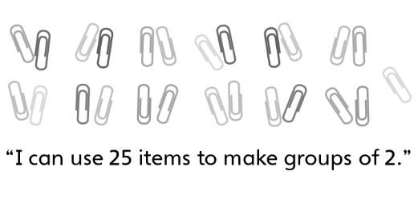 | - Student groups items in 2s, 5s, and 10s, but does not notice any patterns in the chart. | - Student groups items in 2s, 5s, and 10s and  notices patterns in the chart.
Observations/Documentation

