Solving Equal-Grouping Problems Behaviours/Strategies
- Student solves equal-grouping  problem, but miscounts and does  not start with 48 items. | - Student solves equal-grouping  problem, but not all groups are of  the same size.  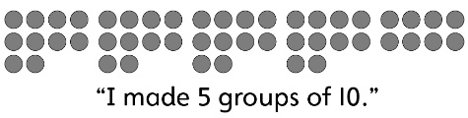 | - Student solves equal-grouping  problem, but ignores the fact that  there are leftover items.  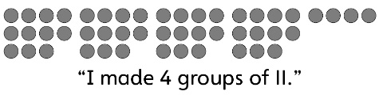 | - Student solves equal-grouping  problem in one way, but struggles to find other ways.  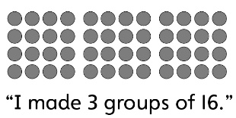
Observations/Documentation
- Student solves equal grouping  problem, but struggles to  represent different ways on paper. | - Student solves equal-grouping  problem, but does not realize that  as the number of items in a group  increases, the number of equal  groups decreases. | - Student solves equal-grouping  problem, but does not recognize  the relationship between opposite  groupings. | - Student successfully solves equal-grouping problem and recognizes all patterns.
Observations/Documentation

