Grouping with and without Remainders Behaviours/Strategies
1. Student creates equal groups, but miscounts when trying to identify equal groups created by others. | 2. Student creates and identifies equal-groups, but not all groups are the same size.  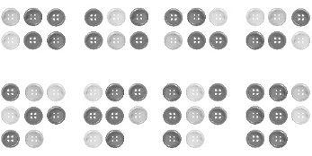 | 3. Student creates and identifies equal groups, but does not identify remainders.  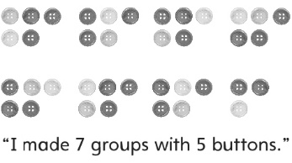 | 4. Student creates and identifies equal groups with and without remainders.  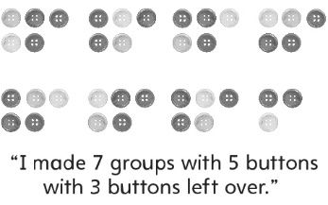
Observations/Documentation

